Deep Learning Framework for Acoustic Myography-Based Hand Gesture Recognition
A Thesis Submitted
In Partial Fulfilment of the Requirements for the Degree of
Bachelor of Technology In

Electronics and Communication Engineering

Submitted by Sankalpa Das 21EC8099
Under the Supervision of Dr. Suman Samui Assistant Professor


ELECTRONICS AND COMMUNICATION ENGINEERING DEPARTMENT
National Institute of Technology Durgapur West Bengal – 713209
India May, 2025


Department of Electronics and Communication
National Institute of Technology Durgapur
Mahatma Gandhi Avenue, Durgapur-713209 West Bengal
India

Bonafide Certificate

This is to certify that Sankalpa Das bearing Roll No. 21EC8099 has successfully completed his project on the thesis entitled, “Deep Learning Framework for Acoustic Myography-Based Hand Gesture Recognition” under my supervision for submission to National Institute of Technology Durgapur towards partial fulfilment for the award of the Degree of Bachelor of Technology in Electronics and Communication Engineering and this thesis is an authentic record of his own work carried out under my supervision.

…………………………………….

Dr. Suman Samui
Assistant Professor,
Electronics and Communication Engineering Department,
National Institute of Technology Durgapur


Department of Electronics and Communication
National Institute of Technology Durgapur
Mahatma Gandhi Avenue, Durgapur-713209 West Bengal
India

Certificate of Approval

The foregoing thesis entitled “Deep Learning Framework for Acoustic Myography-Based Hand Gesture Recognition” is hereby approved as a study of a technology subject carried out in a manner satisfactory to warrant its acceptance as a prerequisite to the degree for which it has been submitted. It is understood that by this approval the undersigned do not endorse or approve any statement made, opinion expressed, or conclusion drawn thereon. The thesis is approved only for the purpose for which it is submitted.

………………………………

Examiner(s)


Department of Electronics and Communication
National Institute of Technology Durgapur
Mahatma Gandhi Avenue, Durgapur-713209 West Bengal
India

DECLARATION

I, Sankalpa Das bearing Roll Number 21EC8099 of B. Tech in Electronics and Communication Engineering hereby declare that my B. Tech. Project / Thesis titled “Deep Learning Framework for Acoustic Myography-Based Hand Gesture Recognition” has been carried out independently by me. I also declare that I have not indulged in any form of plagiarism to carry out the project and while writing this report. The work or ideas of other authors which are utilized in this report has been properly acknowledged and mentioned in the Bibliography. The work presented in this dissertation or any part thereof has not been submitted anywhere else for the award of any degree in another university. I undertake total responsibility if any traces of plagiarism are found at any later stage. In such a case my degree will be cancelled automatically.

Date: May, 2025 Place: NIT, Durgapur

Sankalpa Das
Roll Number: 21EC8099

Acknowledgements

I would like to express my profound gratitude to my project guide, Dr. Suman Samui, for his unwavering support, invaluable guidance, and constant encouragement throughout this research. His expertise and insightful feedback have been instrumental in shaping this work and enabling me to overcome various challenges.
I am also deeply grateful to the faculty and staff of the Department of Electronics and Communication Engineering (ECE) at NIT Durgapur, for providing a resource-rich environment that greatly facilitated my research.
A special thanks to my former project partner, Muskan Jaiswal, for her significant contributions and support during the initial stages of this project in the 7th semester. Her efforts played a pivotal role in laying the foundation for this work.
I extend my heartfelt appreciation to my family and friends for their unwavering support, patience, and constant motivation throughout this journey. Their belief in me has been an endless source of strength.
Finally, I would like to thank all those who contributed, directly or indirectly, to the successful completion of this thesis.

Date: May, 2025 Place: Durgapur

…………………………………………

(SANKALPA DAS)
21EC8099

Abstract

Hand Gesture Recognition (HGR) is essential for intuitive human-computer interaction, especially in assistive and biomedical applications. Traditional methods such as Electromyography (EMG) and vision-based systems often face challenges like sensitivity to environmental conditions and reliance on direct contact. This study explores Acoustic Myography (AMG) as a non-invasive and cost-effective alternative, capturing muscle- generated acoustic signals using microphones placed on the forearm.
We present a deep learning approach using 1D-Convolutional Neural Networks (1D-CNNs), Temporal Convolutional Networks (TCNs), and Long Short-Term Memory (LSTM) models to classify 14 hand gestures from AMG signals sampled at 1024 Hz. The signals were segmented using overlapping time windows (128–250 ms) and processed with a Hamming function.
Analyses in both time and frequency domains revealed that most signal energy lies below 100 Hz, consistently across gestures and subjects. The highest accuracy—94.56%—was achieved using a 1D-CNN with a 250 ms window in the time domain. Frequency-domain models performed slightly lower but revealed distinctive patterns for each gesture. Dimensionality reduction techniques showed clear separation between gesture classes, and model parameters were optimized to improve performance.
Overall, 1D-CNNs offered the best trade-off between accuracy, latency, and complexity, making them suitable for real-time use. These findings highlight AMG’s potential as a scalable and effective alternative to EMG for gesture recognition. Future work will focus on expanding the dataset, improving system robustness, and integrating multiple sensing modalities to enhance real-world applicability.

Nomenclature

Abbreviation | Full form
AMG EMG HGR HCI GPU MMG FMG CNN TCN LSTM t-SNE ROC  Adam Nadam SGD  RMSProp  FLOPS FFT | Acoustic Myography Electromyography  Hand Gesture Recognition Human Computer Interaction Graphics Processing Unit Mechanomyography  Force Myography Convolutional Neural Network  Temporal Convolutional Network Long Short-Term Memory  t-distributed Stochastic Neighbour Embedding Receiver Operating Characteristics  Adaptive Moment Estimation  Nesterov-accelerated Adaptive Moment Estimation Stochastic Gradient Descent  Root Mean Squared Propagation  Floating Point Operations per Second Fast Fourier Transform

List of Symbols

. φ A non-linear activation function
. σ SoftMax function
. 𝓛 Loss Function
. Wres Weights of Residual blocks
. ft Forget Gate

List of Figures

 | Figure No. | Title | Page No.
Chapter 2 | Dataset Description & Feature Engineering
 | 2.1 | Time-domain plots of hand gestures (Classes 1–7) averaged over 8 channels – Subject AA01 | 8
 | 2.2 | Time-domain plots of hand gestures (Classes 8–14) averaged over 8 channels – Subject AA01 | 9
Chapter 3 | Proposed Methodology
 | 3.1 | Hamming Window Function Used for Time-Series Signal Preprocessing | 11
 | 3.2 | 1D-CNN Architecture for Gesture Classification | 12
 | 3.3 | TCN Residual Block | 14
 | 3.4 | Architecture of a Long Short-Term Memory (LSTM) Network | 15
Chapter 4 | Experimental Results
 | 4.1 | Precision, Recall, and F1-Score for Each Gesture Class – Subject AA01 (1D-CNN, 250 ms) | 18
 | 4.2 | Classification Accuracy of 1D-CNN Across Subjects for Varying Window Sizes | 19
 | 4.3 | Comparison of Maximum Classification Accuracy Across Subjects Using CNN, TCN, and LSTM Models | 20
 | 4.4 | t-SNE Visualizations of Feature Representations for 1D CNN, TCN, and LSTM Models Across Time Resolutions | 23
 | 4.5 | Confusion Matrix for AMG-Based Gesture Recognition System | 24

 | Figure No. | Title | Page No.
 | 4.6 | Training, Validation Accuracy and Loss Curves across Epochs | 25
 | 4.7 | ROC Curves for Each Gesture Class in AMG-Based Gesture Recognition | 26
 | 4.8 | Validation and Test Accuracy Using Different Optimizers | 27
 | 4.9 | Validation Loss Variation Across Training Epoch | 28
 | 4.10 | Log-Magnitude Spectrograms of Channel 1 for Subjects AA01 and MJ04 Across All Gesture Classes | 31
 | 4.11 | Power Spectra (Magnitude vs. Frequency) Averaged Over All Channels for Each Hand Gesture Class | 33
 | 4.12 | Time-Frequency Spectrograms of AMG Signals for Different Hand Gestures | 36

List of Tables

 | Table No. | Title | Page No.
Chapter 4 | Experimental Results
 | 4.1 | Average Classification Accuracy (%) for CNN, TCN, and LSTM Models Across Different Window Sizes | 21
 | 4.2 | Optimized Hyperparameters for the 1D-CNN Model | 24
 | 4.3 | Classification Accuracies of CNN, TCN, and LSTM Using Frequency Domain Features Across Window Sizes | 29
 | 4.4 | Quantitative Comparison of 1D-CNN, TCN, and LSTM Across Multiple Metrics and Temporal Resolutions | 30

Contents

Title Page  Bona-fide Certificate |  |  |  | i ii
Certificate of Approval |  |  |  | iii
Declaration |  |  |  | iv
Acknowledgements  Abstract |  |  |  | v  vi
Nomenclature  List of symbols |  |  |  | vii  viii
List of Figures |  |  |  | ix
List of Tables |  |  |  | xi
Table of Contents |  |  |  | xii
Chapter 1 | Introduction |  |  | 1
 | 1.1 | What is AMG Classification? |  | 1
 | 1.2 | Why is AMG Classification Important? |  | 1
 | 1.3 | Applications |  | 1
 |  | 1.3.1 | Biomedical and Rehabilitation | 1
 |  | 1.3.2 | Human-Computer Interaction (HCI) | 1
 |  | 1.3.2 | Industrial and Robotics | 1
 | 1.4 | EMG vs. AMG |  | 2
 | 1.5 | Traditional Methods and Their Drawbacks |  | 2
 |  | 1.5.1 | Electromyography (EMG) Systems | 2
 |  | 1.5.2 | Vision-Based Systems | 2
 | 1.6 | Hybrid Approaches |  | 3
 | 1.7 | Literature Review and Motivation |  | 3

 | 1.8 | Proposed Approach & Novelty |  | 4
 | 1.9 | Contributions |  | 5
Chapter 2 | Dataset Description & Feature Engineering |  |  | 6
 | 2.1 | Dataset Description |  | 6
 | 2.2 | Feature Representation |  | 6
 | 2.3 | Preprocessing Techniques |  | 7
Chapter 3 | Proposed Methodology |  |  | 10
 | 3.1 | Multi-Class Classification Framework |  | 10
 | 3.2 | Preprocessing Pipeline |  | 10
 |  | 3.2.1 | Segmentation & Windowing | 10
 |  | 3.2.2 | Hamming Window Function | 11
 |  | 3.2.3 | Normalization | 11
 | 3.3 | Deep Learning Architectures |  | 11
 |  | 3.3.1 | 1D-Convolutional Neural Network | 12
 |  | 3.3.2 | Temporal Convolutional Network | 13
 |  | 3.3.3 | Long Short-Term Memory | 15
 | 3.4 | Model Training and Optimization |  | 16
 | 3.5 | Evaluation Strategy |  | 17
Chapter 4 | Experimental Results |  |  | 18
 | 4.1 | Model Performance for Single Subject (AA01) |  | 18
 |  | 4.1.1 | Classification Report: Precision, Recall, and F1-Score Analysis | 18
 | 4.2 | Model Performance Across Different Subjects |  | 19
 |  | 4.2.1 | CNN Performance Across Window Resolutions | 19
 |  | 4.2.2 | Architectures performance Comparison across Subjects | 20
 | 4.3 | Accuracy Across Subjects |  | 21
 | 4.4 | t-SNE Visualization |  | 22
 | 4.5 | Hyperparameter Tuning |  | 24
 | 4.6 | Analysis for Hand Movements Classification |  | 25
 |  | 4.6.1 | Confusion Matrix | 25
 |  | 4.6.2 | Accuracy and Loss Evaluation | 26

 |  | 4.6.3 | Receiver Operating Characteristic (ROC) Curves | 27
 | 4.7 | Impact of Optimizer Selection on Model Performance |  | 27
 |  | 4.7.1 | Accuracy Comparison | 28
 |  | 4.7.2 | Loss Convergence Analysis | 28
 | 4.8 | Frequency-Domain Analysis and Model Evaluation |  | 29
 |  | 4.8.1 | Performance of deep learning models on frequency domain AMG signals across window sizes | 29
 |  | 4.8.2 | Multi-Metric Evaluation of Deep Learning Architectures at Different Resolutions | 30
 |  | 4.8.3 | Spectro temporal Analysis of Subject Variability | 31
 |  | 4.8.4 | Power Spectral Characterization of Movements Classes | 32
 |  | 4.8.5 | Spectrogram Analysis of Hand and Wrist Movements for a single subject | 35
Chapter 5 | Discussion |  |  | 38
Chapter 6 | Concluding Remarks and Scope for Future Work |  |  | 39
 | 6.1 | Concluding Remarks |  | 39
 | 6.2 | Scope for Future Work |  | 39
References |  |  |  | 40

CHAPTER-1

INTRODUCTION

What is AMG Classification?
Acoustic Myography (AMG) classification refers to the identification of muscle activity patterns by analysing sound signals generated from muscle contractions. Unlike Electromyography (EMG), which measures electrical signals from muscles, AMG captures mechanical vibrations and acoustic emissions produced by muscle movements. These signals offer a non-invasive and cost-effective alternative for applications such as hand gesture recognition (HGR), prosthetic control, and human-computer interaction.

Why is AMG Classification Important?
Hand Gesture Recognition (HGR) has gained substantial attention in various domains, including assistive technology, robotics, and virtual reality. Traditional systems like EMG and vision-based methods face several limitations, such as high costs, complex calibration processes, environmental sensitivity, and user discomfort. AMG offers a promising solution by providing a contact-free, robust, and affordable approach for real-time hand gesture recognition.

Applications

Biomedical and Rehabilitation
Acoustic Myography (AMG) can be employed in controlling assistive devices and prosthetics, enabling non-invasive, muscle-driven gesture recognition. It also holds promise in rehabilitation scenarios, providing real-time feedback for patients to monitor muscle activity and progress during recovery.

Human-Computer Interaction (HCI)
AMG facilitates touchless control of electronic devices, which is particularly beneficial in sterile or accessibility-critical environments. Its ability to interpret gestures without physical contact supports inclusive and intuitive human-computer interaction.

Industrial and Robotics
In industrial environments, AMG enables hands-free operation of machinery, thereby improving safety and efficiency. It also has significant potential in robotics, particularly in enhancing human-robot collaboration in high-precision tasks such as surgery or remote manipulation.

EMG vs. AMG
While Electromyography (EMG) is widely adopted for gesture recognition, it necessitates direct skin contact with electrodes, rendering it susceptible to noise, skin conditions, and environmental disturbances. EMG systems often require precise electrode placement and extensive calibration, in addition to high-end hardware, limiting their practicality in daily use. In contrast, AMG captures acoustic signals produced by muscle contractions using simple microphone-based sensors, offering a more accessible and adaptable alternative for various environments. Given these limitations of EMG, and other traditional methods, a deeper dive into their specific drawbacks is warranted.

Traditional Methods and Their Drawbacks
Several traditional approaches have been used for muscle activity and gesture recognition, notably Electromyography (EMG)-based and vision-based systems. Despite their widespread adoption, these methods face critical limitations that constrain their utility in real-world, continuous-use scenarios.

Electromyography (EMG) Systems
Electromyography (EMG) is a widely recognized technique that measures the electrical activity generated by skeletal muscles. Surface EMG (sEMG) utilizes skin-surface electrodes to capture muscle activation signals. While effective in controlled environments, EMG systems present several practical limitations.
Firstly, EMG signals are highly vulnerable to external interference, including perspiration, temperature changes, and skin impedance. Perspiration can form a conductive layer between the skin and electrodes, degrading signal quality and introducing artifacts. Zheng et al. [1] and Damecour [2] have shown that sweat accumulation significantly alters the amplitude and power spectrum of EMG signals, complicating interpretation during prolonged or intense use. Furthermore, Petrofsky et al. [3] demonstrated that lower muscle temperatures reduce EMG amplitude and contraction strength, highlighting environmental sensitivity.
Secondly, EMG systems often require precise electrode placement, frequent recalibration, and intensive signal preprocessing to ensure measurement accuracy. These factors increase system complexity and reduce user-friendliness. Additionally, commercial-grade EMG equipment tends to be expensive, making it impractical for large-scale or wearable applications.
Lastly, the requirement for direct skin contact may cause discomfort or irritation during extended use, limiting EMG’s feasibility in long-term, real-time monitoring scenarios.

Vision-Based Systems
Vision-based systems rely on cameras and computer vision algorithms to interpret body posture, limb trajectories, and hand gestures. While offering non-contact interaction and rich spatial data, these systems also present significant drawbacks.

Their primary limitation lies in their reliance on ambient lighting. Poor illumination, shadows, or glare can severely impair recognition performance. Chaaraoui et al. [4] highlight that variable lighting and partial occlusions remain persistent challenges in vision-based monitoring. Additionally, these systems are sensitive to occlusions and changes in viewpoint; gestures or limbs outside the camera’s field of view may be misclassified or missed entirely.
Another concern is the high computational demand of real-time image processing. The use of high-resolution video and deep learning models necessitates substantial computational resources, including GPUs, thereby increasing power consumption, and limiting portability.
Finally, vision-based approaches raise ethical and privacy concerns, particularly in personal or healthcare environments. Continuous visual monitoring can lead to discomfort or user resistance. Pérez et al. [5] emphasize these challenges in the context of assisted living, advocating for privacy-aware solutions.

Hybrid Approaches
To overcome the limitations of the single modality systems such as EMG and vision-based systems, hybrid systems have been developed. Although standalone AMG systems have demonstrated strong performance, integrating AMG with other modalities such as Mechanomyography (MMG) or Force Myography (FMG) can enhance system robustness. Multimodal sensing, such as EMG-MMG combinations, has been shown to improve classification accuracy in prosthetic control and gesture recognition tasks. Studies report accuracies exceeding 90% using such hybrid systems, illustrating the effectiveness of multimodal integration.

Literature Review and Motivation
The classification of myoelectric signals has been a key area of research in the development of intuitive and reliable human-computer interfaces, particularly in applications involving upper- limb prosthetic control and gesture recognition. Over the past decade, numerous studies have focused on optimizing EMG-based systems through advancements in signal processing, feature extraction, and classifier design. A prominent challenge in this domain is ensuring high classification accuracy under varying limb positions and minimizing the complexity of real- time deployment.
Shaikh et al. [7] addressed the issue of robustness in myoelectric controllers by proposing a multi-objective optimization strategy using evolutionary computation. Their method emphasized minimizing false activations during rest states while maintaining high classification accuracy, a critical consideration in real-world prosthetic control systems. This study highlighted the importance of balancing accuracy with reliability during idle periods, offering a performance trade-off often overlooked in traditional classification systems.

Mukhopadhyay and Samui [8] presented an experimental study that employed a deep neural network (DNN) for upper-limb EMG signal classification across varying limb positions. Their work demonstrated the effectiveness of fused time-domain descriptors (fTDD) as a lightweight yet powerful feature representation, allowing subject-specific DNN models to achieve high accuracy without the need for complex preprocessing or feature reduction techniques. This approach significantly reduced the computational burden and made real-time deployment more feasible, particularly when classifying signals from multiple upper-limb postures.
Building on the limitations of standalone classifiers, Samui et al. [6] introduced a heterogeneous stacking ensemble framework that combines multiple base learners (SVM, KNN, logistic regression, decision tree) with meta-learners (random forest and multi-layer perceptron). Their approach outperformed individual classifiers, demonstrating enhanced generalization and robustness in EMG classification tasks, especially under limb position variability. The framework achieved superior accuracy across multiple subjects and test configurations, making it a promising architecture for real-time control systems.
Motivated by the strengths and limitations of these prior works, the present study focuses on AMG-based gesture recognition using deep learning techniques. Unlike EMG, AMG signals are non-electrical in nature and provide an alternative sensing modality that is less affected by skin impedance and external noise. By drawing from the architectural insights of DNN models
[8] , the performance enhancement strategies of ensemble learning [6] , and the robustness considerations in control-oriented optimization [7] , this work aims to explore an efficient and position-invariant classification framework for AMG signal-based hand gesture recognition.

Proposed Approach & Novelty
This study presents an AMG-based deep learning framework for Hand Gesture Recognition (HGR), employing advanced neural network architectures such as 1D-Convolutional Neural Networks (1D-CNN), Temporal Convolutional Networks (TCN), and Long Short-Term Memory (LSTM) models. Unlike traditional methods, the proposed approach distinguishes itself by:
- Utilizing AMG signals for non-invasive gesture recognition.
- Implementing multi-resolution windowing techniques (128 ms, 192 ms, and 250 ms) to enhance feature extraction.
- A comparative analysis of time-domain and frequency-domain representations revealed that raw time-domain AMG signals provided more stable classification performance, especially for deep learning models. Consequently, the proposed method processes raw signals directly in the time domain without transformation, preserving temporal characteristics and reducing preprocessing complexity.
- Use of 50% overlapping segmented windows to capture dynamic temporal patterns.

- Applying a Hamming window function to reduce spectral leakage and improve signal clarity.
This innovative approach maximizes the utility of raw AMG data and advanced deep learning models, offering an effective solution for real-time gesture recognition.

Contributions
This research makes the following key contributions:
- Development of an AMG-based HGR system: We present a robust hand gesture recognition system using Acoustic Myography (AMG) signals, achieving high accuracy without the need for complex or advanced data preprocessing techniques.
- Application of raw data: The proposed system is based on raw AMG data, avoiding frequency domain transformations, which makes it a more accessible approach for real- time gesture recognition applications.
- Implementation of multi-resolution windowing: We implemented a multi-resolution windowing technique (128 ms, 192 ms, and 250 ms windows with 50% overlap) to enhance temporal feature extraction, which improves the recognition performance.
- Evaluation of deep learning models: We explored the use of deep learning models— 1D-CNN, Temporal Convolutional Networks (TCN), and Long Short-Term Memory (LSTM) networks—for AMG classification. This evaluation provides insights into the effectiveness of these models for real-time applications.

CHAPTER-2

Dataset Description & Feature Engineering

Dataset Description

The dataset used in this study was sourced from Google Drive link, which contains eight- channel Acoustic Myography (AMG) signals. Data were collected from 10 subjects (5 male and 5 female) to ensure diversity and generalizability in gesture recognition tasks.

The dataset includes recordings of 14 distinct hand gestures performed by the subjects: Pronation, Supination, Wrist Flexion, Wrist Extension, Radial Deviation, Ulnar Deviation, Hand Close, Hand Open, Hook Grip, Fine Pinch, Tripod Grip, Index Finger Flexion, Thumb Finger Flexion, and a resting state (No Movement).

For data acquisition, subjects were seated comfortably with their forearms resting on an armrest positioned on a table. Eight AMG sensors were placed on the upper forearm to capture muscle vibrations effectively. Participants were instructed to perform transient, moderate-force muscle contractions lasting between 2 and 4 seconds for each gesture.

To assist with gesture execution and maintain consistency, the subjects were allowed to monitor their real-time AMG signals on a display screen. Each gesture was repeated 20 times, with rest intervals of 2-3 seconds between repetitions. Recordings were conducted in a controlled indoor setting, with an ambient background noise level of approximately 35 dB, to reduce environmental interference.

The dataset and the data acquisition process were adapted from the methodology described in Al-Timemy et al. (2022), which focuses on hand gesture recognition using AMG and wavelet scattering transform [10] .

Feature Representation

For initial signal exploration, time-domain plots were used to visualize and compare the characteristics of different gesture classes. In contrast to conventional frequency-domain analysis, the raw AMG data was directly used for classification, preserving the temporal characteristics essential for gesture recognition.

To evaluate how temporal resolution influences classification performance, the dataset was prepared using three different window lengths, forming three separate datasets per subject:
- 128 ms window: Captures fine-grained, short-duration muscle activities.
- 192 ms window: offers a balance between temporal precision and contextual richness.

- 250 ms window: provides a broader temporal context, potentially capturing more global gesture dynamics.

These temporal resolutions were selected to capture both fine and broad variations in muscle activity, facilitating a more robust gesture classification process.

Preprocessing Techniques

The following preprocessing steps were applied to enhance the quality of the recorded AMG signals data and create different resolutions datasets and ensure reliable feature extraction:

- Segmentation with 50% overlap: Each AMG signal was divided into overlapping windows with 50% overlap. This technique preserved continuity in gesture transitions and minimized the loss of temporal information.
- Hamming Function Application: A Hamming window is applied to each segmented window to minimize discontinuities at the edges, reducing spectral leakage and improving model stability.
- Normalization: Each signal was normalized to reduce inter-subject variability and improve model generalization across different subjects.

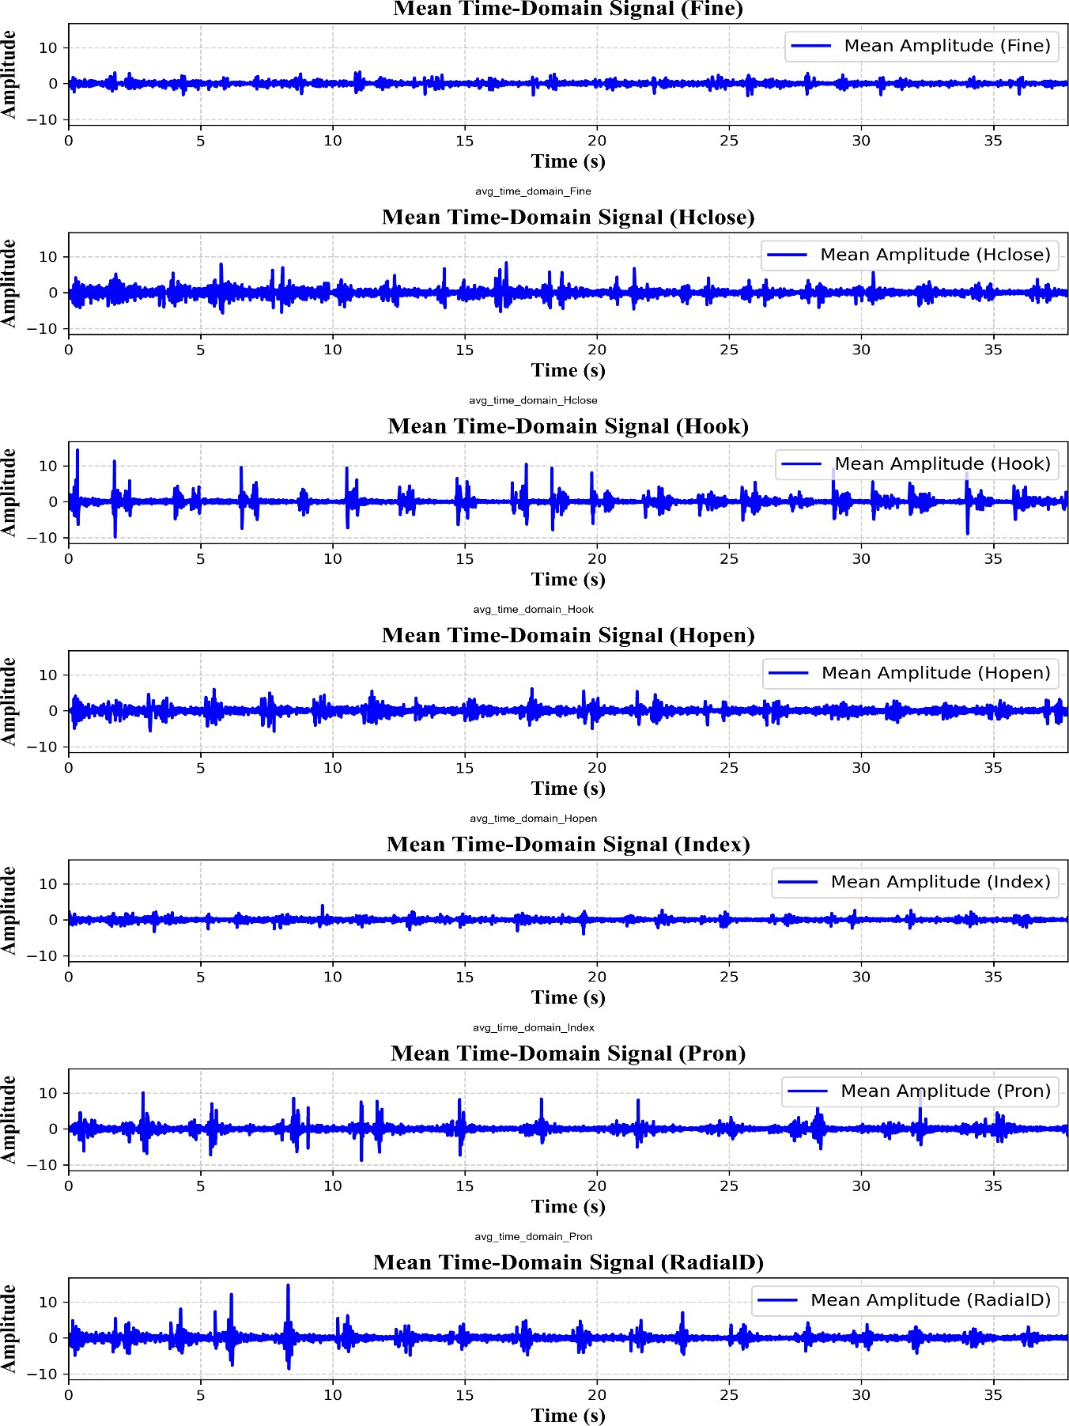

Figure 2.1: Time-domain plots of hand gestures (Classes 1–7) averaged over 8 channels – Subject AA01

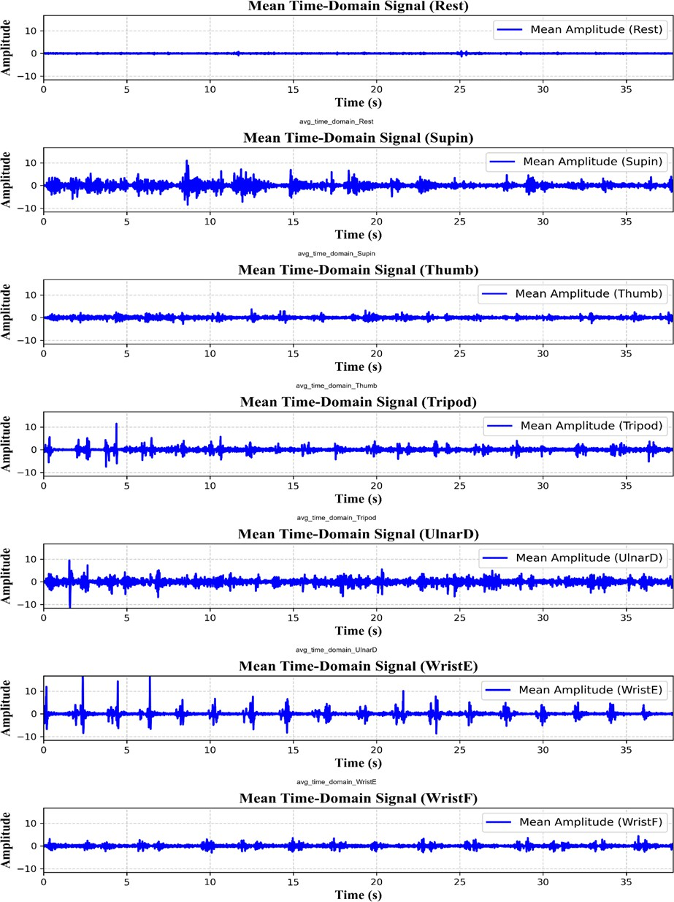

Figure 2.2: Time-domain plots of hand gestures (Classes 8–14) averaged over 8 channels – Subject AA01

CHAPTER-3

Proposed Methodology

Multi-Class Classification Framework

The proposed AMG-based Hand Gesture Recognition (HGR) system is designed as a multi- class classification framework. This framework processes raw AMG signals and classifies them into one of the 14 distinct hand gestures. The framework consists of the following core components:
- Preprocessing Pipeline: Transforms raw AMG signals into model-ready input through segmentation, windowing, and normalization.
- Deep Learning Architectures: Implements specialized deep learning models—1D Convolutional Neural Networks (1D-CNN), Temporal Convolutional Networks (TCN), and Long Short-Term Memory (LSTM) networks—to automatically learn and extract relevant features from sequential AMG signals.
- Model Training and Optimization: Trains the models using supervised learning techniques and enhances performance via hyperparameter tuning.
- Evaluation Metrics: Measures model performance using accuracy, precision, recall, and confusion matrix analysis.

Preprocessing Pipeline

The preprocessing pipeline ensures the raw AMG signals are appropriately prepared for deep learning model input. The following steps were applied:
    - Segmentation & Windowing: Each continuous AMG signal is segmented into overlapping windows with 50% overlap to preserve temporal continuity and minimize information loss. The number of samples per window is computed as:
Window Size (ms)
𝑆𝑎𝑚𝑝𝑙𝑒𝑠 𝑝𝑒𝑟 𝑊𝑖𝑛𝑑𝑜𝑤 = 𝑓𝑠 × ( ) 1000
where 𝑓𝑠 =1024 Hz is the sampling frequency of the signal.

    - Hamming Window Function: To smooth the transitions at segment boundaries and reduce spectral leakage, a Hamming window is applied to each segmented window. The Hamming window function is defined as:

w(n) = 0.54 − 0.46 ∗ cos (
2πn
)
N − 1

where w(n) is the window value at index n, N is the window length (number of samples), and n∈ {0, 1, ..., N−1}.
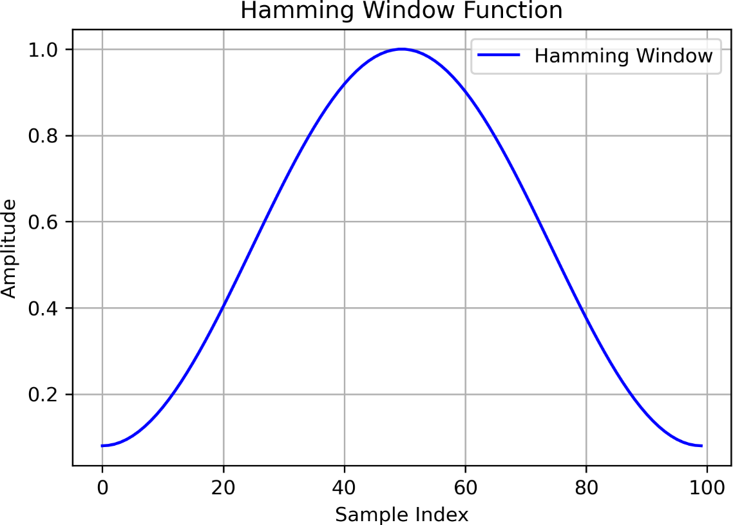
Figure 3.1: The Hamming window function. Its application ensures smoother transitions and reduces discontinuities, which is critical for accurate time-series feature extraction.

    - Normalization: Signal normalization was performed to mitigate inter-subject variability and standardize amplitude differences. This step improves model generalization and ensures consistency across different recording sessions and subjects.

Deep Learning Architectures

To classify the AMG signals, three distinct deep learning models were implemented, each designed to handle specific characteristics of the sequential AMG data:

1D-Convolutional Neural Network (1D-CNN)
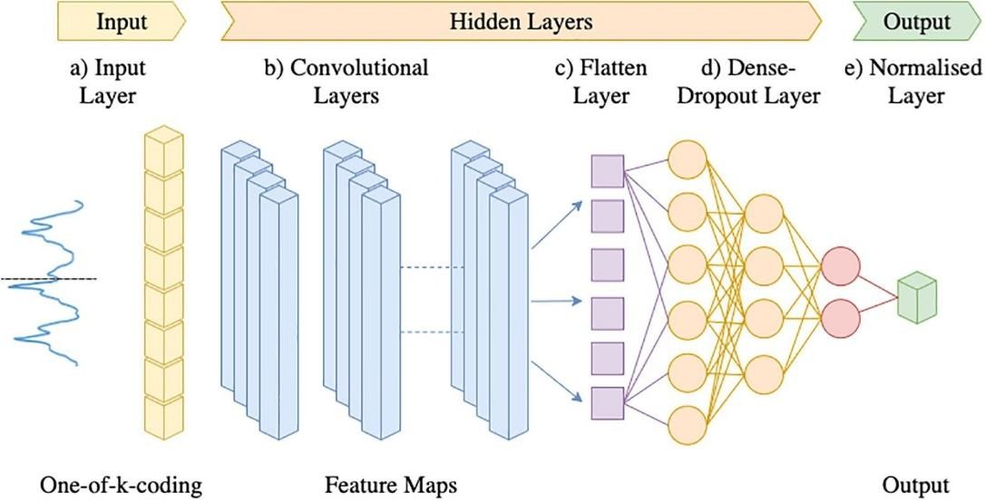
Figure 3.2: 1D-CNN Architecture for Gesture Classification. Source: [9] .

1D Convolutional Neural Networks (1D CNNs) are widely used for extracting local features from sequential data such as time series and biomedical signals. Their architecture comprises convolutional layers, non-linear activation functions, pooling layers, and fully connected layers.

Input Representation
Let the input signal be:
where T is the sequence length is 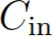 the number of input channels.

Convolutional Layer
The convolution operation for the l-th layer is given by:
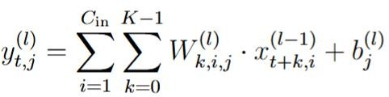

where K is the kernel size, W^{(l)} and b^{(l)} are the weights and biases, respectively. A non- linear activation function φ (e.g., ReLU) is applied:
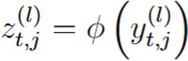

Pooling Layer
To reduce spatial dimensionality:
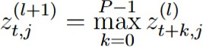
where P is the pooling window size.

Fully Connected Layer
After flattening:

where σ is SoftMax as it is a Multi-class classification problem.

Loss Function
For multi-class classification:
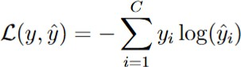

End-to-End Learning
The network models a function :

and is optimized via gradient descent to minimize L.

    - Temporal Convolutional Network (TCN): The TCN uses dilated causal convolutions to efficiently capture sequential dependencies within the AMG signals. This network is optimized to handle long sequences of data while maintaining high processing speed and minimizing computational overhead.

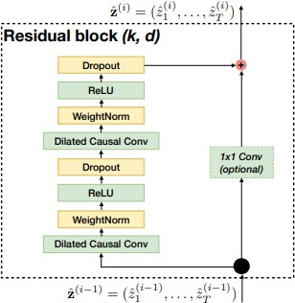

Figure 3.3: TCN residual block. Source: [12]

Input Representation
      - Causal Convolution
Ensures temporal order is preserved:


Dilated Convolution
With dilation factor d:
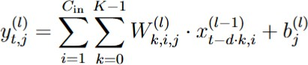

Residual Blocks
Residual learning improves training:
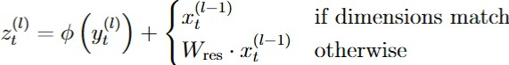

Output Layer and Loss

Final prediction uses SoftMax:
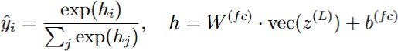

Loss is computed as:
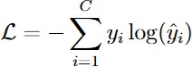

    - Long Short-Term Memory (LSTM) Network: LSTM networks are well-suited for sequential data as they capture long-range dependencies. Their ability to remember information over long periods makes them ideal for handling the temporal dynamics inherent in AMG signals, such as muscle contraction patterns over time.
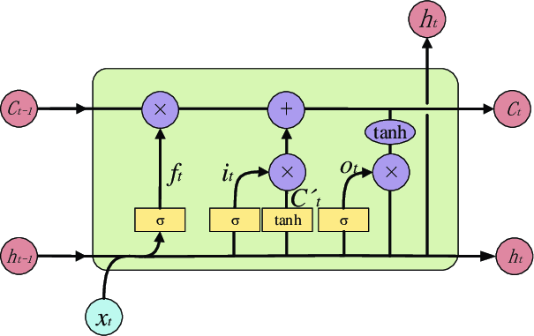
Figure 3.4: Architecture of a Long Short-Term Memory (LSTM) Network. Source: [11]

      - Forget Gate
      - Input Gate and Candidate Cell State
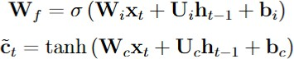

      - Cell and Output State Update
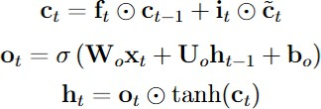
      - Loss Function
Like CNN and TCN, a SoftMax output and Categorical cross-entropy loss are used.

Model Training and Optimization

The dataset was first split into two parts: 80% for training and 20% for testing. The 80% training data was further split into 80% for actual training and 20% for validation. This validation set is used to tune and optimize the model parameters to achieve the best performance.
To enhance model performance and save time, hyperparameter tuning was employed using Keras Tuner. Hyperparameter tuning ensures the best possible hyperparameters are selected by testing different combinations, allowing for the identification of the best model for each architecture. This process efficiently identifies the optimal learning rate, number of convolutional filters, and dropout rates, thereby improving the model’s performance while minimizing training time.
Once the best-performing model was created using the training and validation data, it was evaluated on the separate 20% test dataset to ensure generalization to unseen data.

Evaluation Strategy

This validation set was used to tune and optimize the model's parameters, ensuring that the best model was selected before testing on the separate 20% test dataset.
The following metrics were used to assess the performance of the model:

- Accuracy: Represents the overall effectiveness of the classification model by measuring the percentage of correctly classified gestures out of all predictions.

Precision & Recall:

  - Precision measures the correctness of the model's positive predictions, indicating how many of the predicted gestures were correct.
  - Recall measures the completeness of the model's positive predictions, indicating how many of the actual gestures were correctly identified by the model.
- Confusion Matrix: This provides a detailed view of how each gesture was classified, highlighting misclassifications, and offering insights into where the model might be confused between certain gestures. The confusion matrix helps in understanding the robustness of the model across all gesture classes.
The final model, after hyperparameter tuning and optimization, was evaluated on the test dataset to ensure that it generalizes well to unseen data. This thorough evaluation strategy ensures that the AMG-based HGR system delivers high accuracy and reliability for gesture recognition.

CHAPTER-4

Experimental Results

Model Performance for Single Subject (AA01)

Classification Report: Precision, Recall, and F1-Score Analysis
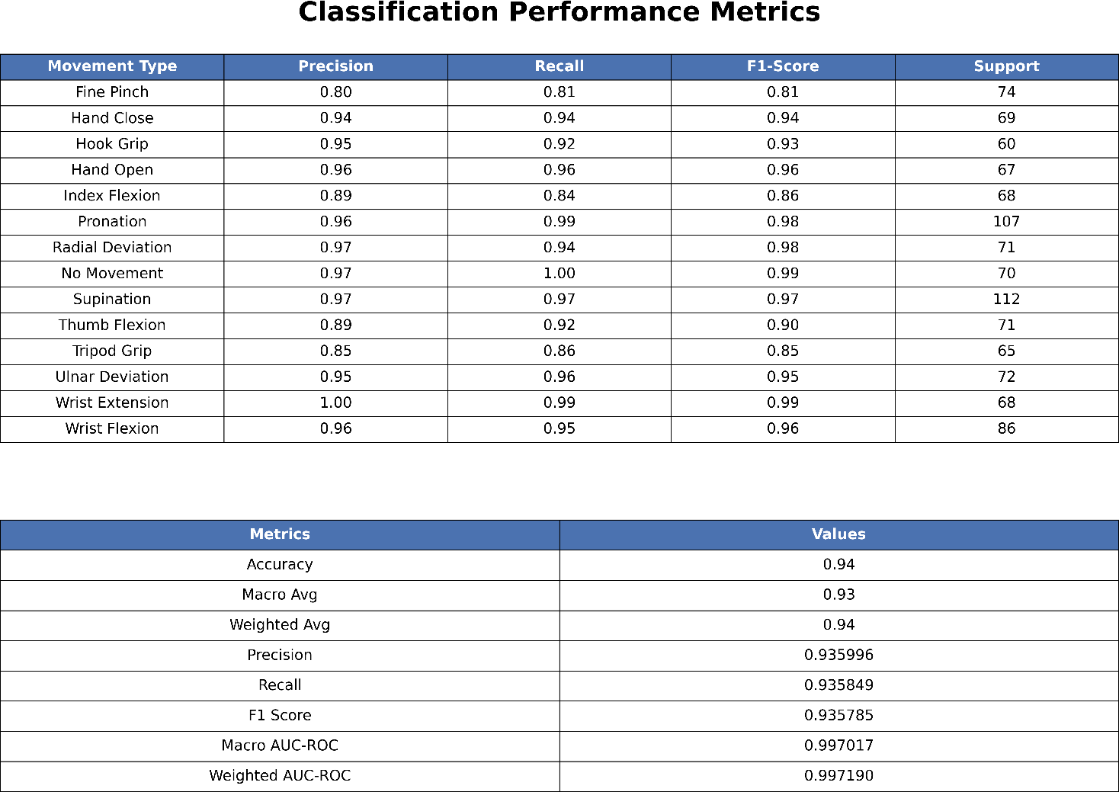

Figure 4.1: Precision, recall, and F1-score for each of the 14 gesture classes for subject AA01, obtained using the 1D-CNN model
with a 250 ms window. These metrics provide detailed insight into the model’s classification performance and its ability to distinguish between different hand movements

Observations:
      - The model achieves an overall accuracy of 94%, demonstrating robust classification performance.
      - High precision (>0.95) and recall (>0.95) are observed for most classes, indicating minimal false positives and false negatives.
      - The Wrist Extension gesture achieves a perfect F1-score of 1.00, indicating flawless classification.

      - The Fine Pinch and Tripod Grip gestures show relatively lower performance, with precision and recall around 0.80 and 0.81, suggesting some misclassifications.
      - The macro-average and weighted-average F1-scores are 0.93 and 0.94, respectively, confirming that the model maintains balanced performance across all gesture classes.
      - The AUC-ROC scores are close to 1.0, reinforcing the model’s ability to differentiate between gesture classes.
These results validate the effectiveness of AMG signals for hand gesture classification, confirming that deep learning-based approaches can achieve high accuracy for real-time applications in assistive technology and human-computer interaction.

Model Performance Across Different Subjects

CNN Performance Across Window Resolutions
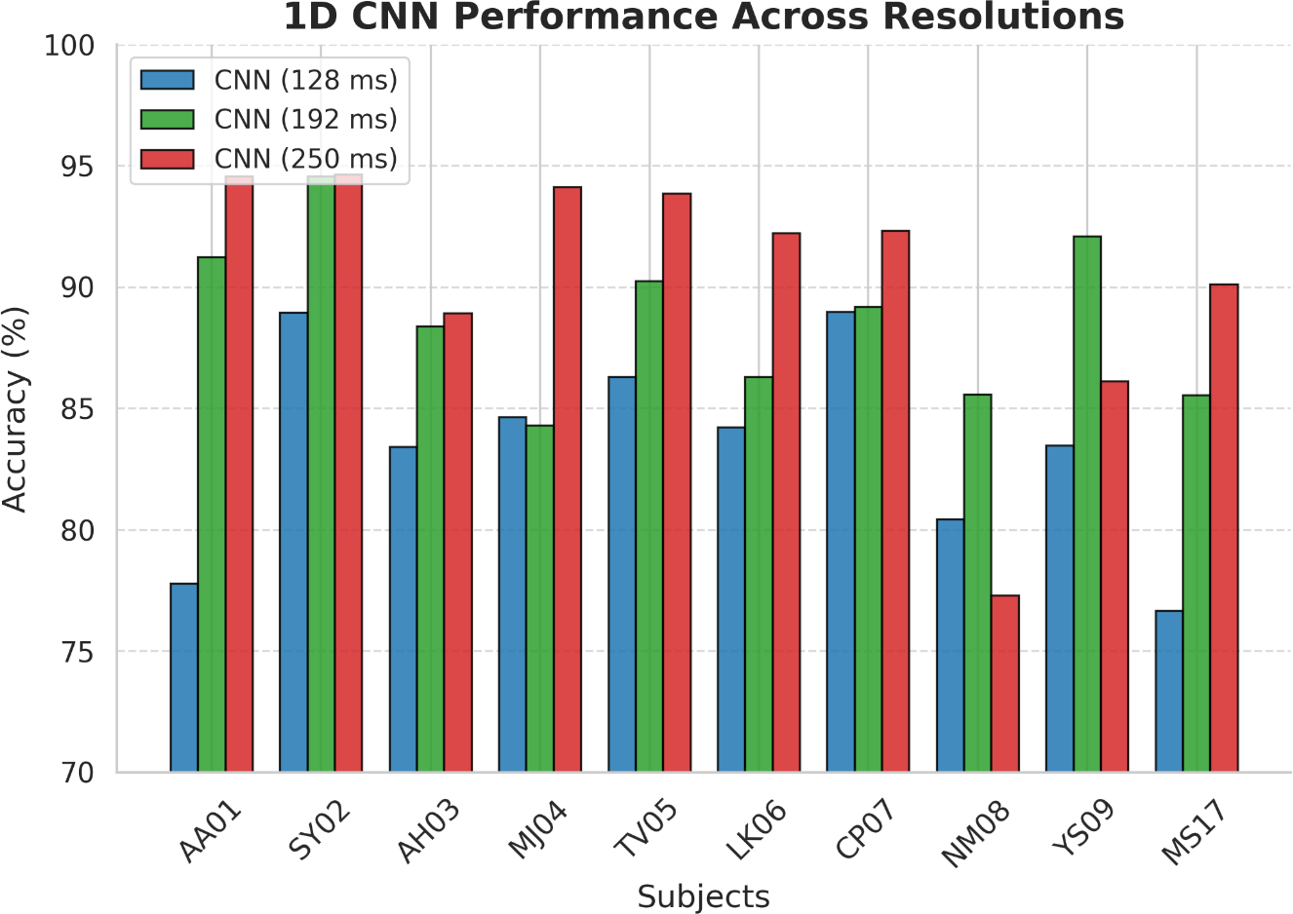
Figure 4.2: Classification accuracy of the 1D-CNN model across multiple subjects using three different window sizes: 128 ms, 192 ms, and 250 ms.

Figure 4.2 shows the classification accuracy of the 1D-CNN model across multiple subjects using three different window sizes: 128 ms, 192 ms, and 250 ms. The results consistently indicate that larger window sizes lead to improved accuracy, emphasizing the critical role of

temporal context in AMG-based gesture classification. These findings suggest that longer windows provide more comprehensive features from the AMG signals, allowing the model to make more accurate predictions.

Observations:

      - The CNN model with a 250 ms window achieves the best performance, highlighting the importance of longer temporal contexts in AMG signal classification.
      - While the 192 ms window also performs well, the 128 ms window shows comparatively lower accuracy, suggesting that shorter time segments may not capture sufficient discriminative features.

Architectures performance Comparison across Subjects

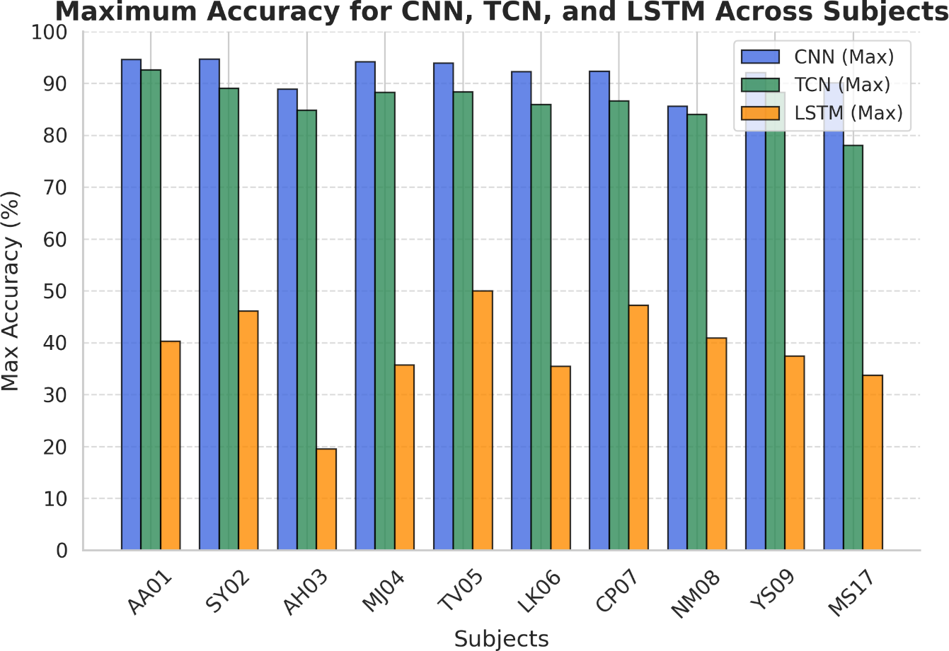
Figure 4.3: Maximum classification accuracy achieved by CNN, TCN, and LSTM models across different subjects in the AMG-based Hand Gesture Recognition (HGR) task.

Figure 4.3 presents the maximum classification accuracy achieved by CNN, TCN, and LSTM architectures across different subjects in the AMG-based Hand Gesture Recognition (HGR) task. The CNN model consistently outperforms the other architectures, achieving the highest accuracy for all subjects, followed by the TCN model, which demonstrates comparable but

slightly lower performance. In contrast, the LSTM model exhibits significantly lower accuracy, with notable subject-to-subject variations. This trend suggests that convolution-based architectures (CNN and TCN) are more effective in capturing spatial-temporal dependencies in AMG signals, whereas the sequential nature of LSTM may limit its ability to extract discriminative features effectively. These results further validate the suitability of AMG signals for robust gesture classification and emphasize the effectiveness of convolutional models in real-time HGR applications.

Accuracy Across Subjects

In addition to evaluating overall model performance, we also analysed the accuracy of each model across all subjects. The accuracy plot revealed that:
- 1D-CNN consistently showed the highest accuracy across most subjects, with fewer fluctuations in performance.
- TCN performed well but demonstrated slight variations between subjects, indicating sensitivity to temporal structure.
- LSTM showed the most variation in performance, with several subjects achieving below-average accuracy, further supporting the idea that LSTM models might not be optimal for AMG-based gesture recognition.

Model | 128 ms | 192 ms | 250 ms
CNN | 83.87 | 89.60 | 90.79
TCN | 81.65 | 84.93 | 86.95
LSTM | 37.61 | 31.33 | 26.39
Table 4.1: Average Accuracy for Each Resolution Across All Subjects for Each Model in Time Domain

The values presented in the Table 4.1 above represent the average accuracy for each model across all subjects at varying window sizes (128 ms, 192 ms, and 250 ms). The CNN model consistently outperforms both the TCN and LSTM models across all window sizes, achieving the highest accuracy values.

In contrast, the LSTM model exhibits a substantial decline in performance as the window size increases, suggesting potential limitations in its ability to handle larger temporal windows effectively.

t-SNE Visualization

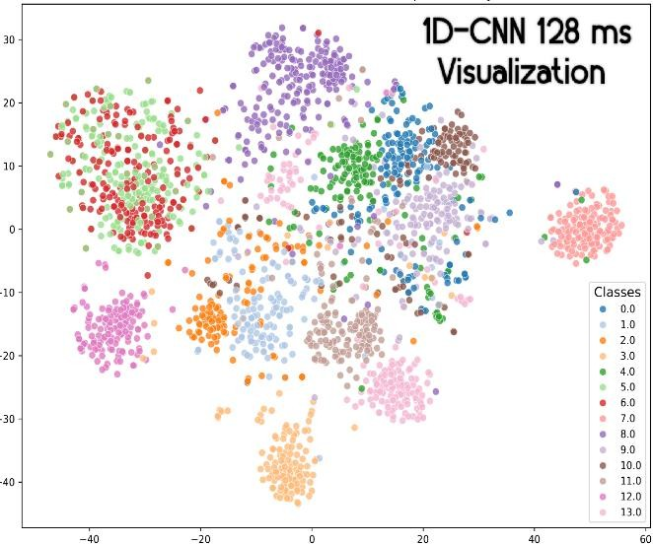  (a) | 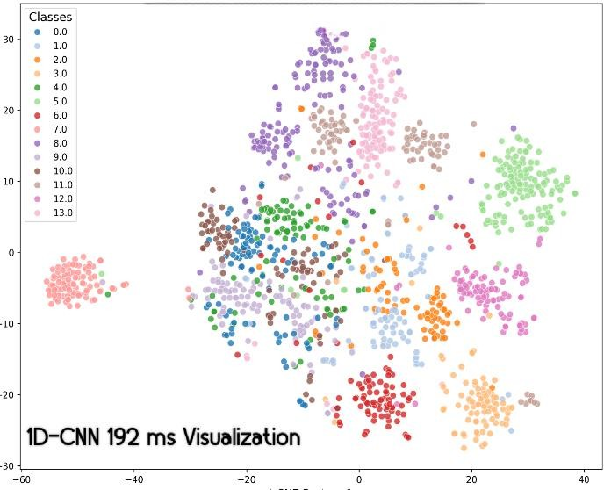  (b)
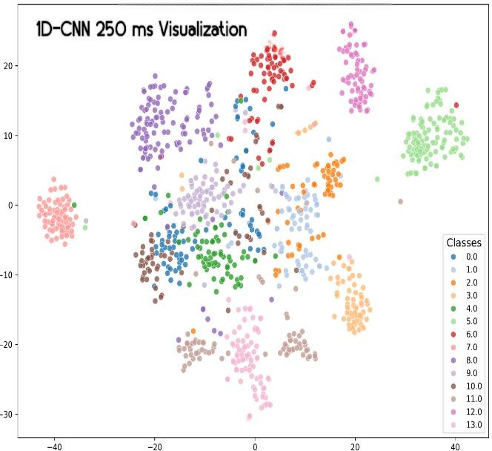  (c) | 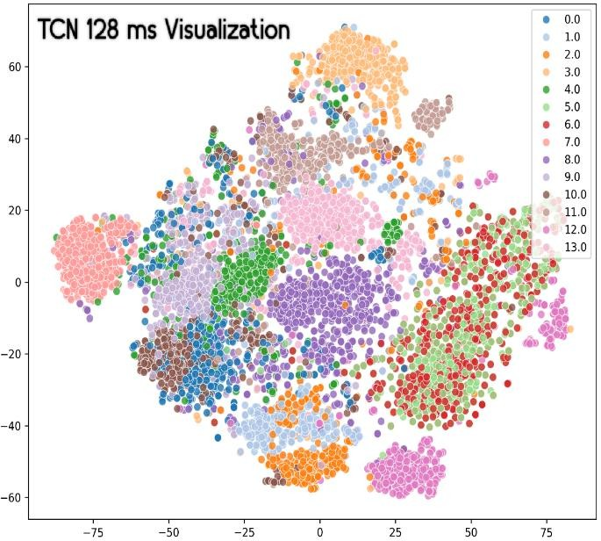  (d)

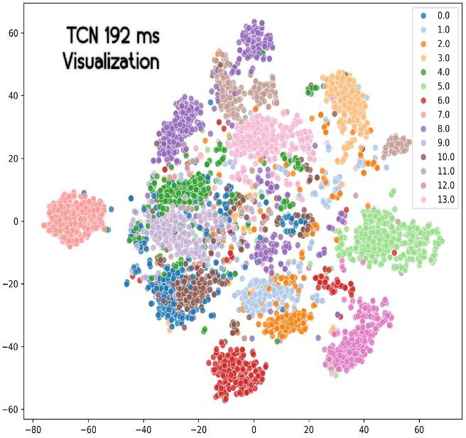  (e) | 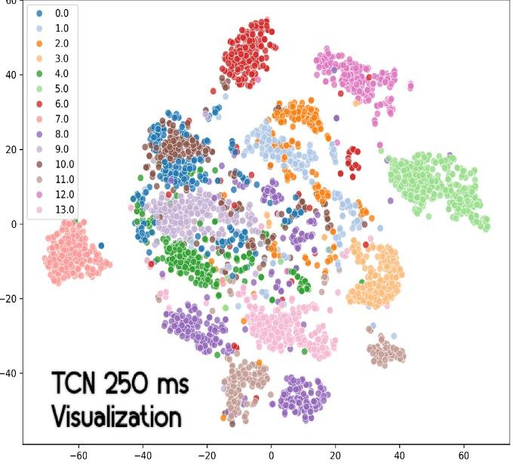  (f)
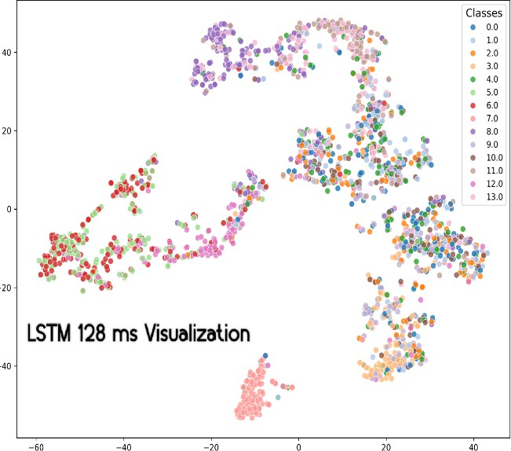  (g) | 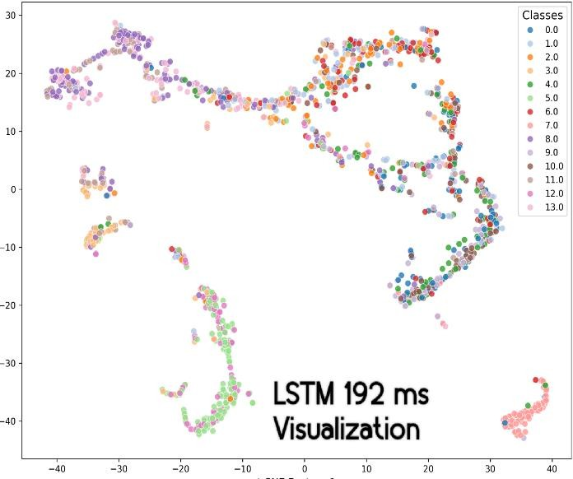  (h)
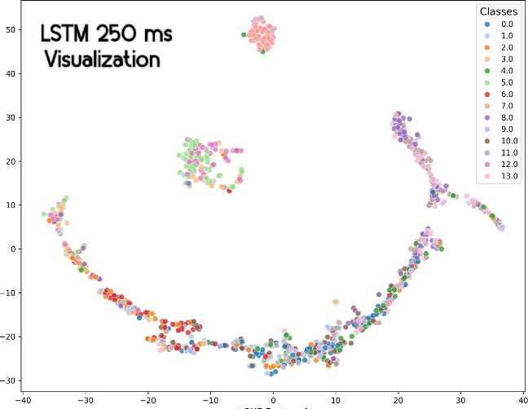
(i)
Figure 4.4: t-SNE visualizations of feature representations for different models and time resolutions. (a) 1D CNN (128 ms), (b) 1D CNN (192 ms), (c) 1D CNN (250 ms), (d) TCN (128 ms), (e) TCN (192 ms), (f) TCN (250 ms), (g) LSTM (128 ms), (h) LSTM (192 ms), (i)LSTM (250 ms).

Figure 4.4 illustrates the t-SNE visualizations of feature representations extracted from different models (1D CNN, TCN, and LSTM) across three-time resolutions (128 ms, 192 ms, and 250 ms). The 1D CNN model exhibits the most distinct and well-separated clusters, indicating strong feature extraction capabilities. In contrast, the TCN model shows moderate separability, with certain clusters being less distinct, suggesting potential overlap in feature space. The LSTM model demonstrates the highest degree of overlap among gestures, implying that sequential dependencies captured by LSTM might lead to less discriminative representations. Overall, the differences in cluster compactness and separability highlight how each model processes AMG signals differently across varying time resolutions.

Hyperparameter Tuning

Hyperparameter tuning was conducted using Keras Tuner to optimize model performance. Key parameters such as the learning rate, dropout rate, and the number of convolutional filters (for CNN) or units (for LSTM) were fine-tuned. The best-performing 1D-CNN model achieved 93.596% accuracy with the following optimized hyperparameters. The hyperparameters for the 1D-CNN model are summarized in Table 2.

Layer Type | Filters/Units | Kernel Size | Activation
Conv 1 | 128 | 3 | ReLU
Conv 2 | 224 | 5 | ReLU
Conv 3 | 320 | 7 | ReLU
Dense | 384 | — | ReLU
Dropout | 0.2 | — | —
Optimizer | Adam | — | —
Table 4.2: Optimized Hyperparameters for the 1D-CNN Model

Analysis for Hand Movements Classification

Confusion Matrix
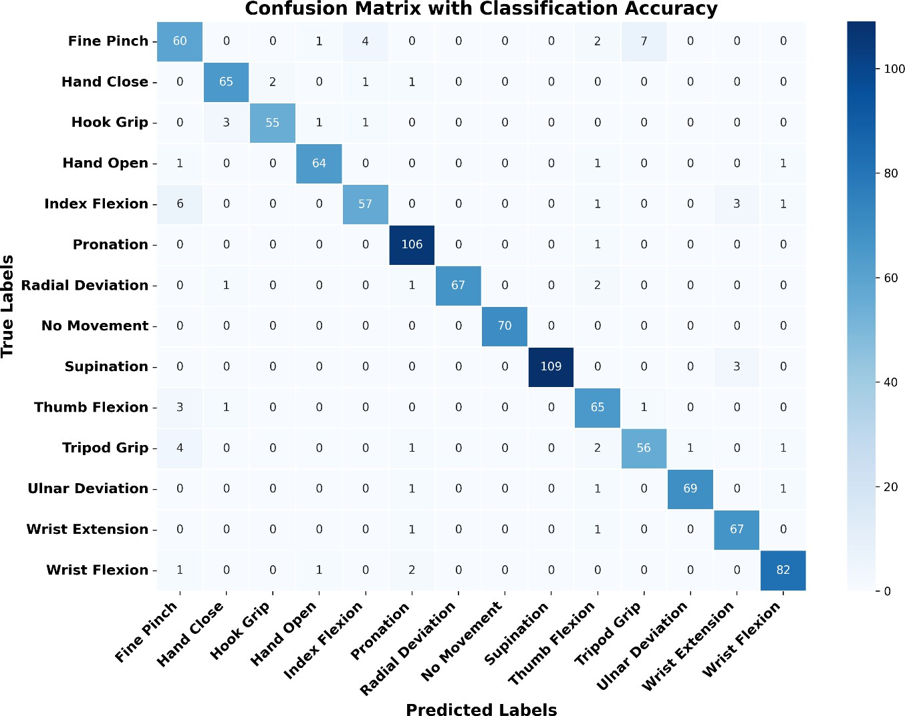

Figure 4.5: Confusion matrix for the AMG-based gesture recognition system, showing high classification accuracy across gestures.

Figure 4.5 presents the confusion matrix for the proposed AMG-based gesture recognition system, illustrating the classification accuracy across different hand gestures. The system demonstrates high performance, with most gestures being classified correctly. Gestures such as "Pronation" (99.1%), "Wrist Flexion" (95.3%) and "Supination" (99.2%) exhibit near- perfect recognition, indicating the robustness of the model. The diagonal dominance of the matrix suggests that the system effectively distinguishes between most gestures with minimal confusion. However, some degree of misclassification is observed, particularly among gestures with similar acoustic characteristics, which could be attributed to overlapping spectral features or biomechanical similarities.

Notable misclassifications include "Fine Pinch" being confused with "Hook Grip" and "Wrist Flexion," which may result from shared signal patterns. Similarly, the "Tripod Grip" gesture shows minor confusion with "Fine Pinch," likely due to the similarity in muscle activation. Despite these occasional errors, the overall classification accuracy remains high, highlighting the effectiveness of the AMG-based system in recognizing a diverse set of gestures. These results demonstrate the potential of the proposed approach for reliable hand gesture recognition, with minimal confusion between distinct classes.

Accuracy and Loss Evaluation
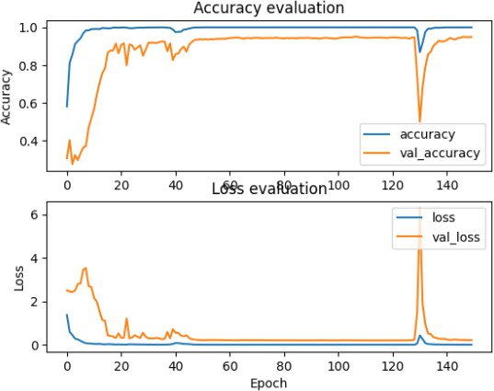
Figure 4.6: Training and validation accuracy (top) and loss (bottom) curves over the training epochs.

The accuracy plot of Figure 4.6 shows that both training and validation accuracy increase rapidly within the initial epochs and stabilize close to 1.0, indicating effective learning. However, a sudden drop in accuracy around 130 epochs suggests a possible disruption, such as overfitting or learning rate decay. The loss plot mirrors this trend, with training and validation loss decreasing significantly over time, except for a sharp spike around the same

epoch. This anomaly may indicate instability in training, requiring further investigation into hyperparameter tuning or regularization techniques.

Receiver Operating Characteristic (ROC) Curves
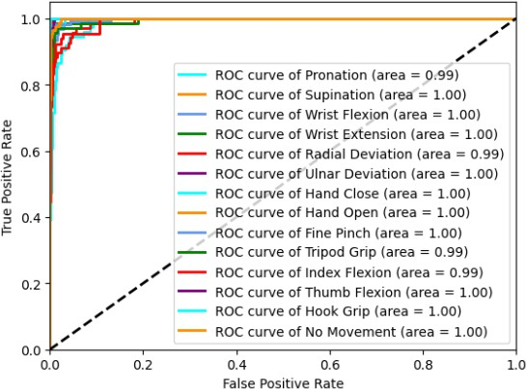
Figure 4.7: ROC curves for each gesture class, demonstrating the model’s ability to distinguish between gestures.

In Figure 4.7 the high area under the curve (AUC) values (mostly 1.00, with some at 0.99) suggest near-perfect classification performance. The curves remain close to the top-left corner, confirming a high true positive rate with a minimal false positive rate. These results demonstrate the robustness of the model in recognizing gestures with strong discriminative power.

Impact of Optimizer Selection on Model Performance

To investigate the influence of different optimization strategies on the AMG-based HGR system, we evaluated the performance of five optimizers—Adam, AdamW, Nadam, RMSprop, and SGD. The evaluation was based on validation accuracy, test accuracy, and loss convergence behaviour.

Accuracy Comparison
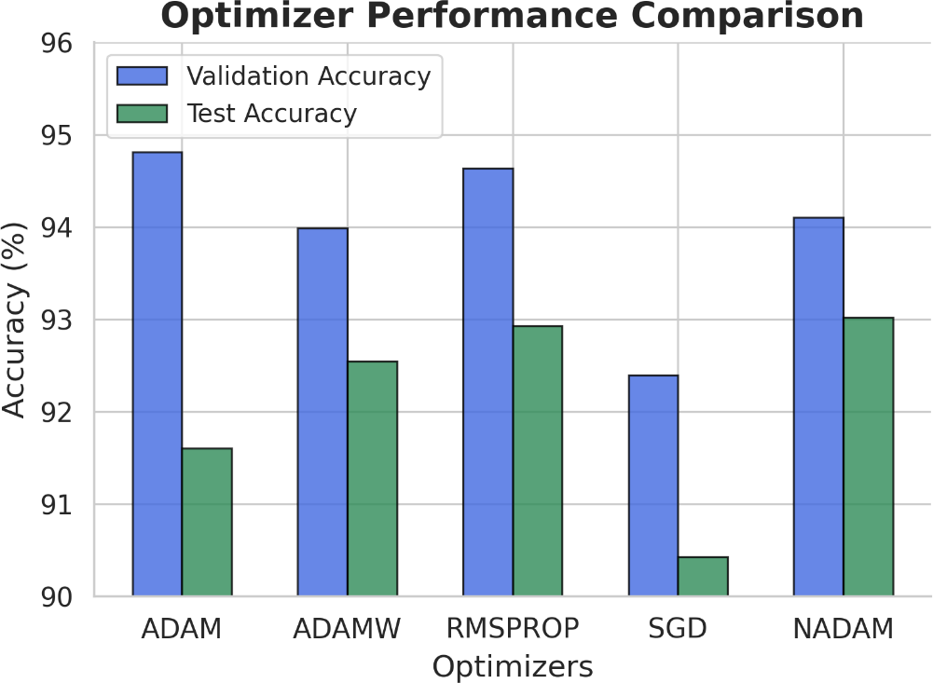
Figure 4.8: Validation and test accuracy for different optimizers.
Figure 4.8 illustrates the validation and test accuracy achieved using different optimizers. Adam and Nadam exhibited the highest test accuracy, followed closely by RMSprop. In contrast, SGD yielded the lowest accuracy, highlighting its slower convergence. AdamW performed competitively but showed slightly lower test accuracy than Adam and Nadam.
Adam and Nadam achieved the highest accuracy, followed by RMSprop, while SGD had the lowest. AdamW showed similar performance but slightly lagged Adam and Nadam.

Loss Convergence Analysis

Figure 4.9 shows the validation loss trends across training epochs for different optimizers. Adam and Nadam display smooth and stable convergence, making them the most effective for

this task. RMSprop and AdamW show greater fluctuation, indicating sensitivity to tuning. SGD converges more slowly, requiring more epochs to reach competitive performance.

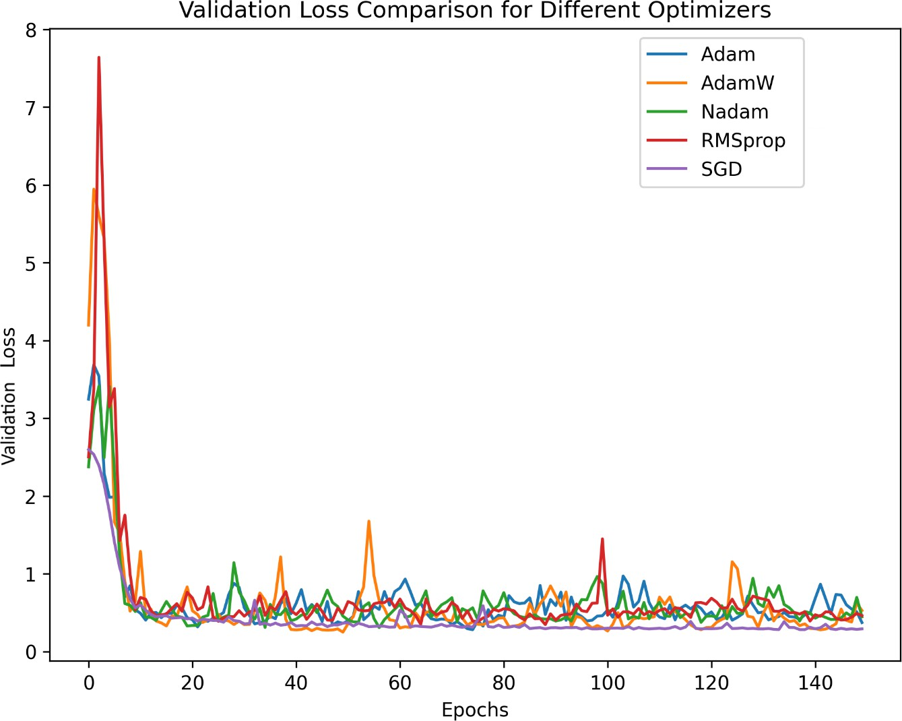
Figure 4.9: Validation loss variation across training epochs for different optimizers.

Frequency-Domain Analysis and Model Evaluation

Performance of deep learning models on frequency domain AMG signals across window sizes

Model | 128 ms | 192 ms | 250 ms
CNN | 78.344 | 79.559 | 84.418
TCN | 82.640 | 83.192 | 86.281
LSTM | 39.736 | 38.247 | 38.935
Table 4.3: Classification Accuracies of CNN, TCN, and LSTM Using Frequency Domain Features Across Window Sizes

Table 4.3 reports the classification accuracies (%) of CNN, TCN, and LSTM models trained on FFT-based frequency-domain AMG signals across window sizes of 128 ms, 192 ms, and 250 ms. TCN consistently achieves the highest accuracy, peaking at 86.281% with a 250 ms window. CNN also performs well, reaching 84.418% at 250 ms. In contrast, LSTM shows significantly lower accuracy at all window sizes, highlighting its limited effectiveness for frequency-domain features.
    - Multi-Metric Evaluation of Deep Learning Architectures at Different Resolutions
Resolution: 128 ms

Architecture | FLOPs | Latency (Mean ± Std. Dev.) | Accuracy (%) | Model Size (MB)
1D-CNN | 42,498,580 | 65.382 ms ± 10.591 ms | 77.778 | 3.106
TCN | 45,429,728 | 132.291 ms ± 25.677 ms | 78.258 | 3.078
LSTM | 2,452,134 | 239.431 ms ± 80.356 ms | 40.278 | 8.835
Resolution: 192 ms

Architecture | FLOPs | Latency (Mean ± Std. Dev.) | Accuracy (%) | Model Size (MB)
1D-CNN | 68,501,812 | 80.772 ms ± 26.318 ms | 91.224 | 4.112
TCN | 66,969,888 | 123.543 ms ± 24.606 ms | 88.289 | 2.353
LSTM | 2,634,504 | 305.348 ms ± 82.732 ms | 34.893 | 8.474
Resolution: 250 ms

Architecture | FLOPs | Latency (Mean ± Std. Dev.) | Accuracy (%) | Model Size (MB)
1D-CNN | 92,603,572 | 93.362 ms ± 63.666 ms | 94.562 | 8.930
TCN | 87,079,968 | 112.993 ms ± 16.199 ms | 92.568 | 3.078
LSTM | 3,582,459 | 367.427 ms ± 109.280 ms | 38.211 | 8.474

Table 4.4 (a), (b), (c): Comparison of 1D-CNN, TCN, and LSTM models across accuracy, latency, FLOPs, and parameter count for three input window sizes (128 ms, 192 ms, 250 ms) in frequency-domain AMG classification.

Table 4.4 compares 1D-CNN, TCN, and LSTM models across FLOPs, latency, accuracy, and parameter count at three input resolutions (128 ms, 192 ms, and 250 ms) for frequency-domain AMG classification.
At 128 ms, TCN achieves the highest accuracy (78.258%) but with high latency. 1D-CNN offers comparable accuracy (77.778%) with significantly lower latency and similar complexity. LSTM shows the lowest accuracy (40.278%) and the highest latency, indicating poor suitability. At 192 ms, 1D-CNN improves to 91.224% accuracy, outperforming both TCN and LSTM. TCN offers a good balance with fewer FLOPs, while LSTM continues to underperform. At 250 ms, 1D-CNN reaches peak accuracy (94.562%) with reasonable latency and computation. TCN remains competitive, but LSTM still lags in performance. Overall, 1D-CNN consistently delivers the best balance of accuracy and efficiency, making it the most suitable model for this task.

Spectro temporal Analysis of Subject Variability
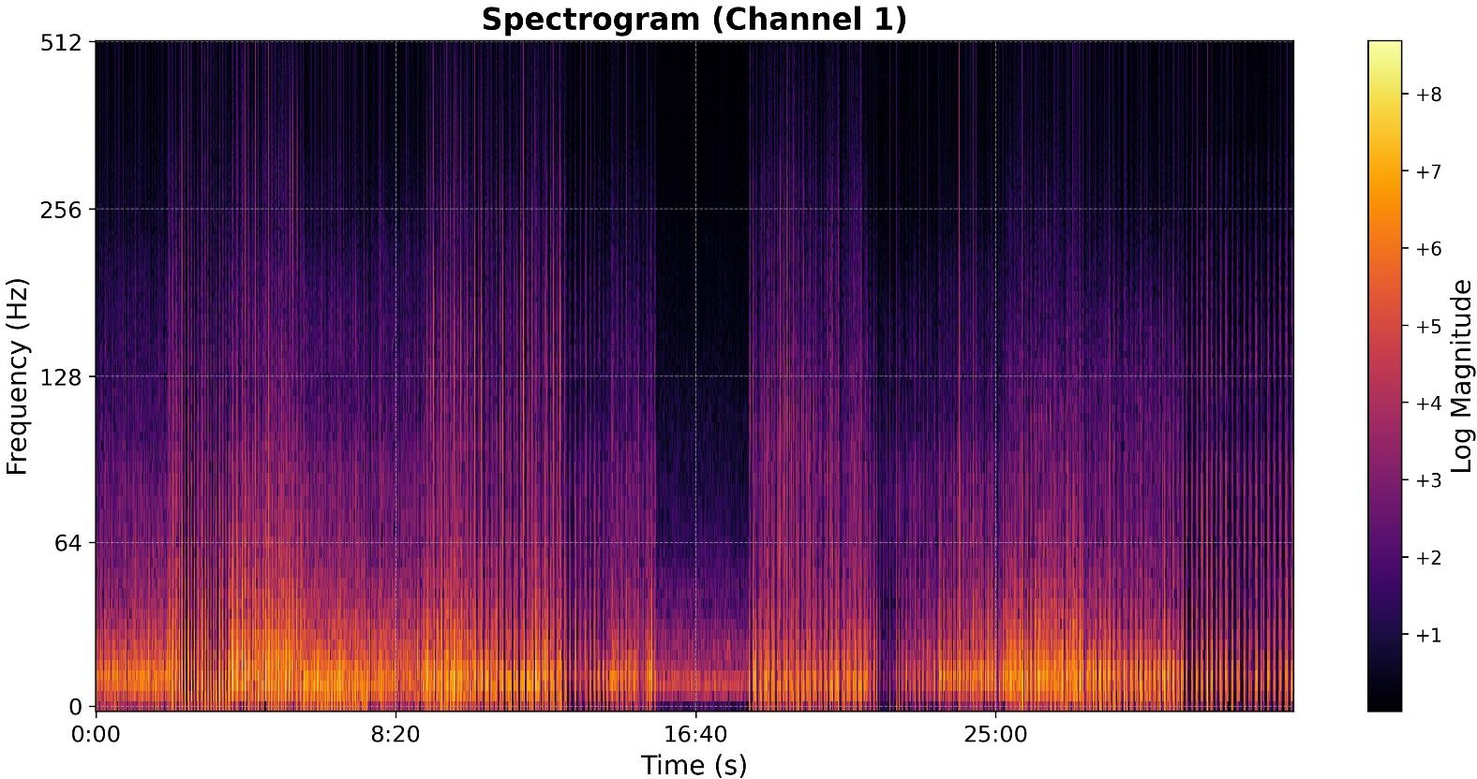
Figure 4.10(a): Log-magnitude spectrogram of Channel 1 for subject MJ04 across all gesture classes, showing a similar low-frequency energy concentration.

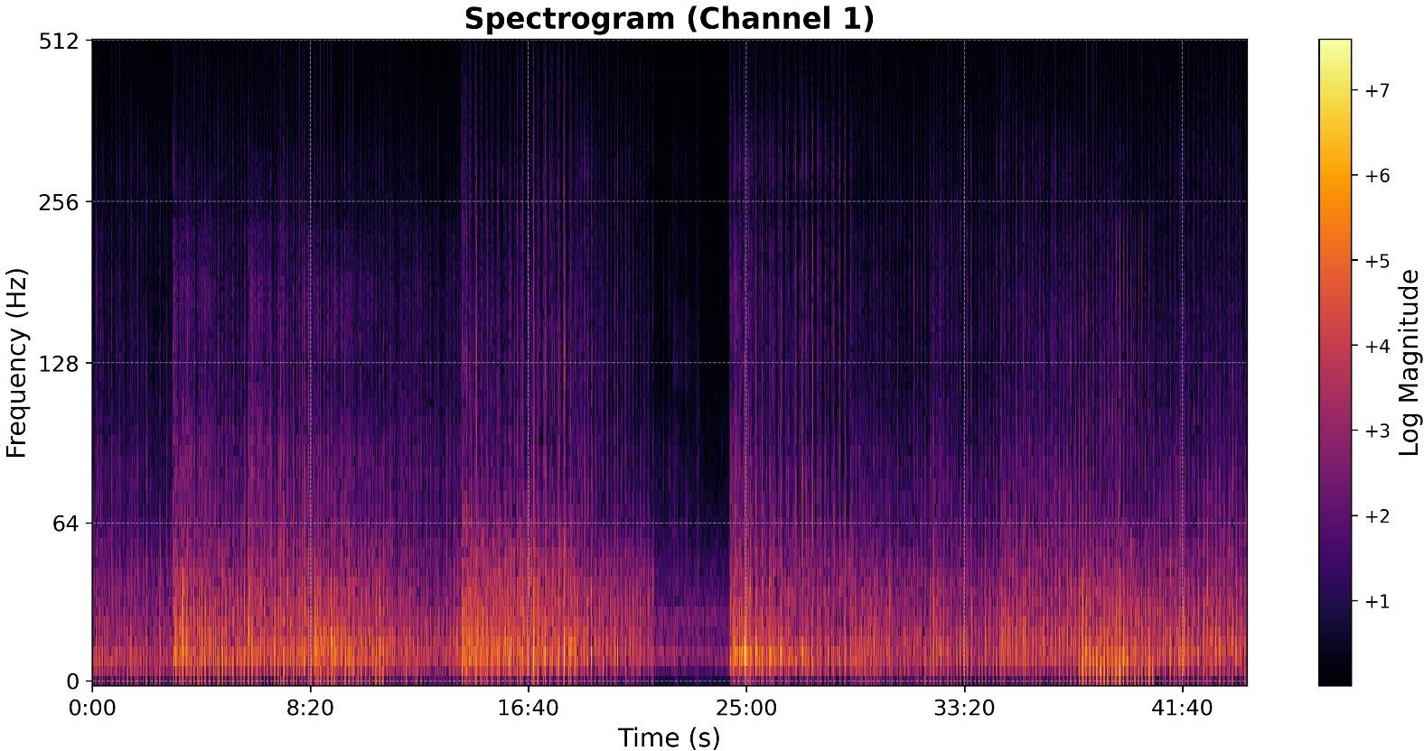
Figure 4.10(b): Log-magnitude spectrogram of Channel 1 for subject AA01 across all gesture classes. Most energy is concentrated in the 0–64 Hz range.
Figure 4.10 displays the log-magnitude spectrograms of Channel 1 for two subjects, AA01 and MJ04, encompassing all gesture classes. In both cases, the spectral energy is predominantly concentrated in the lower frequency range (0–64 Hz), with a gradual attenuation observed at higher frequencies—a characteristic typical of AMG signals. Temporal segments corresponding to gesture activity are distinctly visible, interspersed with intervals of relative inactivity. While the overall spectral patterns are comparable between the two subjects, subtle differences in spectral intensity and distribution can be observed. These variations may reflect individual differences in muscle activation dynamics or anatomical characteristics.

Power Spectral Characterization of Movements Classes

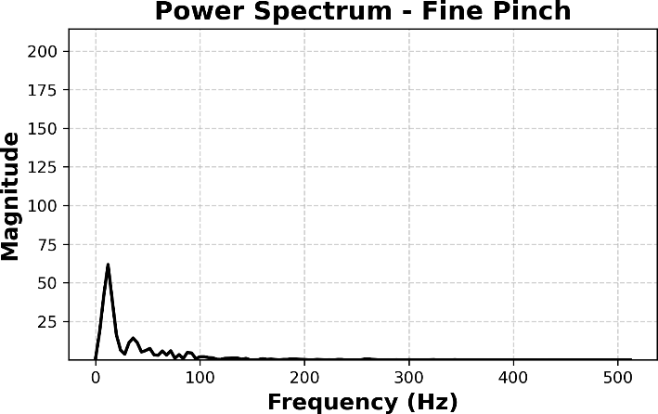 | 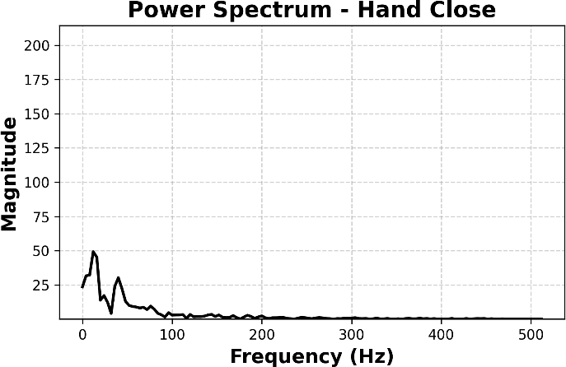

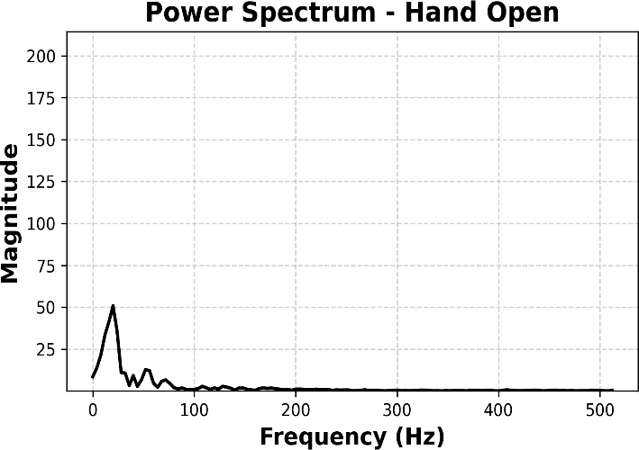 | 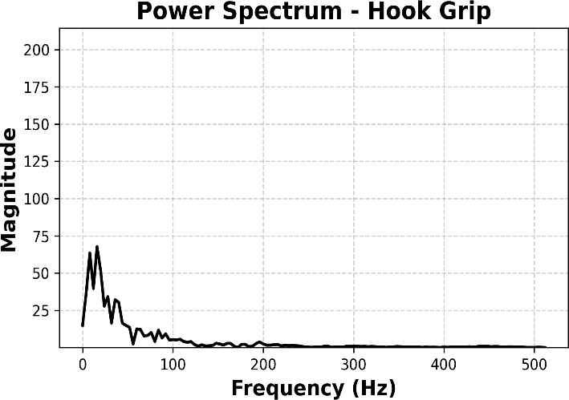
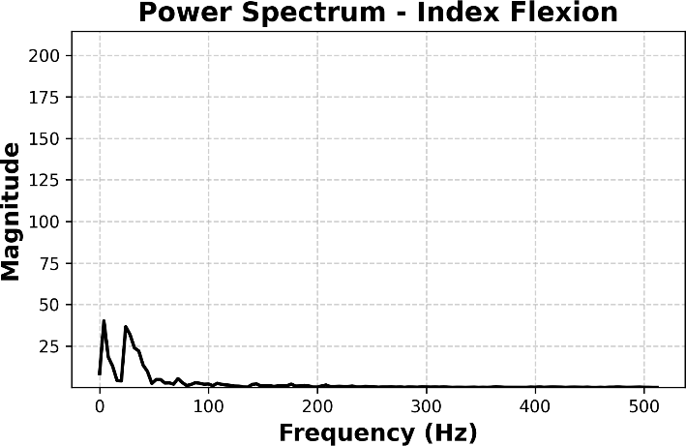 | 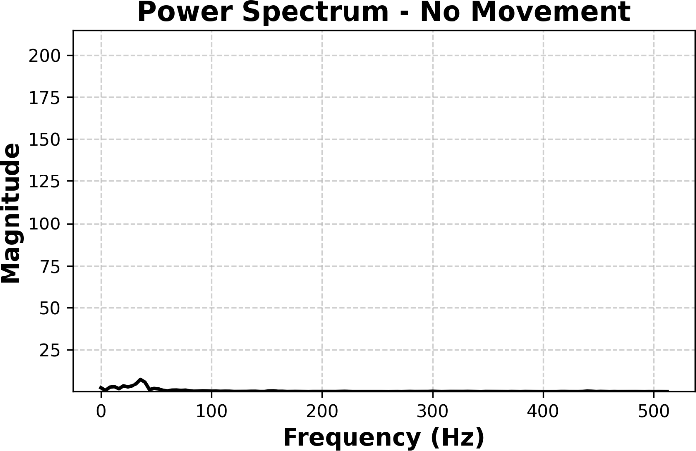
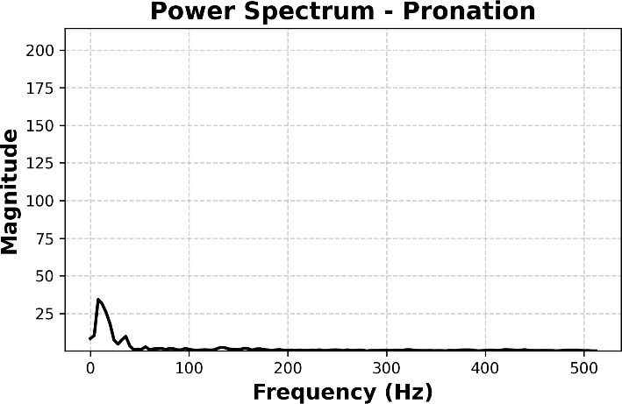 | 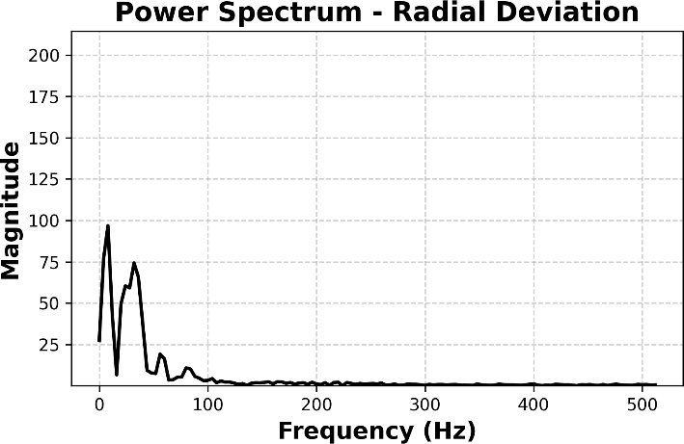
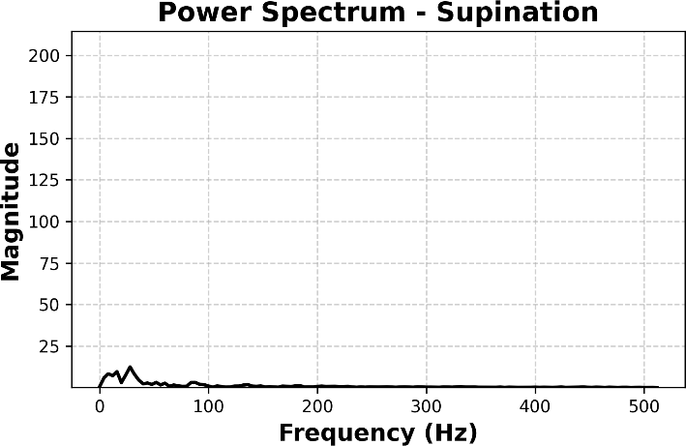 | 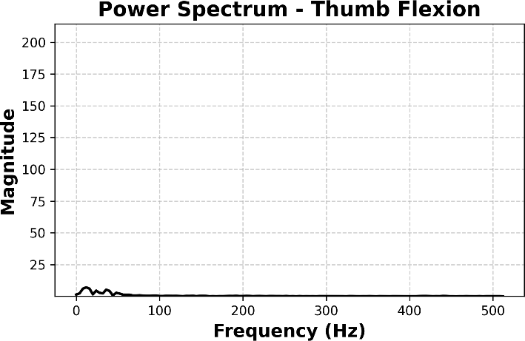

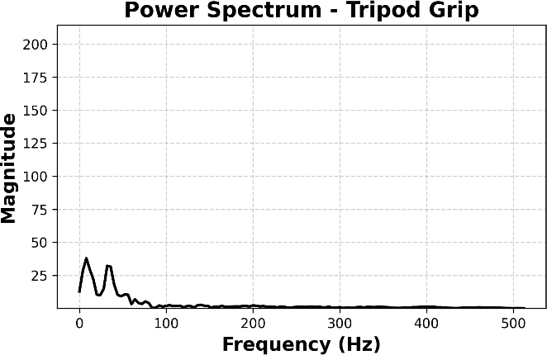 | 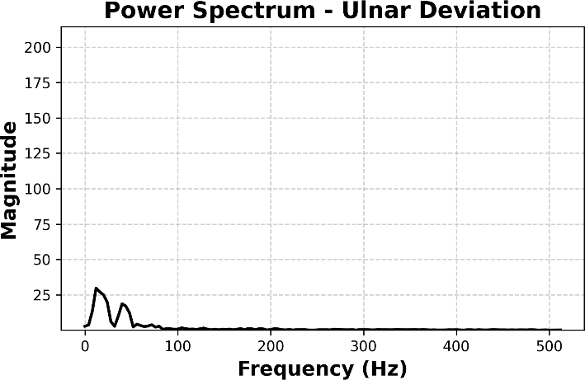
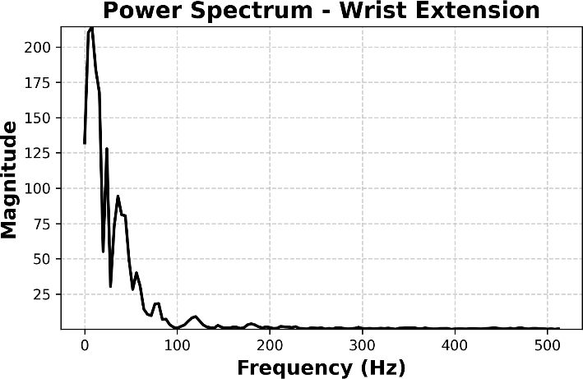 | 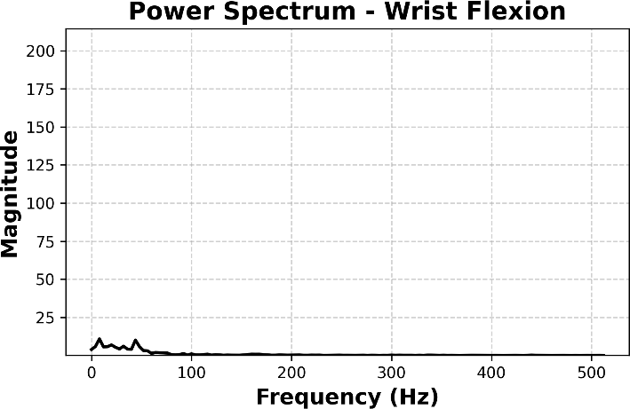

Figure 4.11: Mean power spectral plots for different movement class.

Figure 4.11 presents the power spectra (magnitude vs. frequency) averaged over all channels for each of the 14 hand gesture classes. Each plot reflects the mean spectral response corresponding to a specific gesture. Across all classes, the spectral energy is predominantly concentrated below 100 Hz, with gesture-dependent variations in magnitude and frequency distribution. These distinctions in spectral profiles highlight the discriminative potential of frequency domain features and support their relevance for AMG-based gesture classification.

Spectrogram Analysis of Hand and Wrist Movements

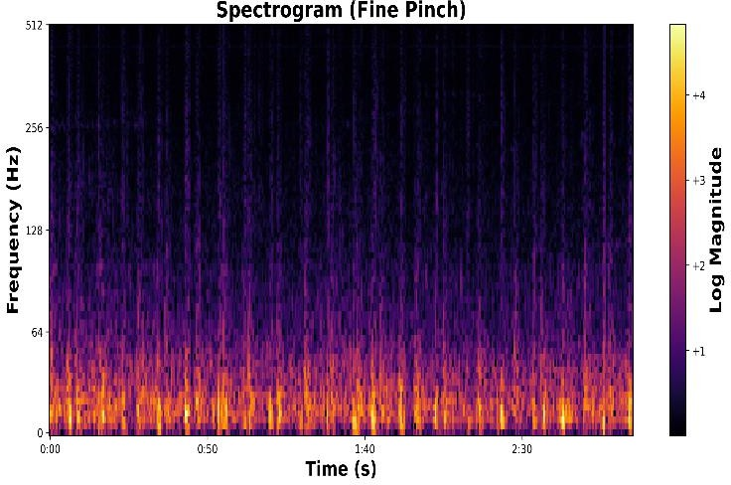  Fine_Pinch | 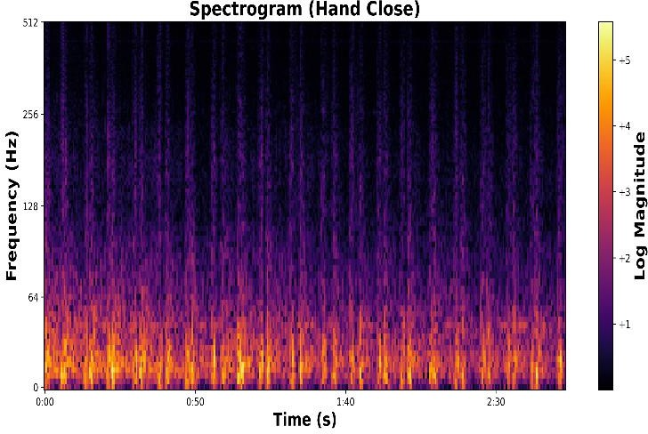  Hand_Close
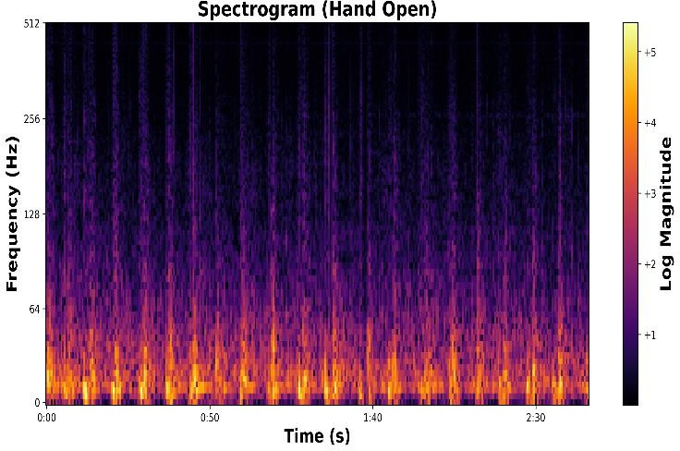  Hand_Open | 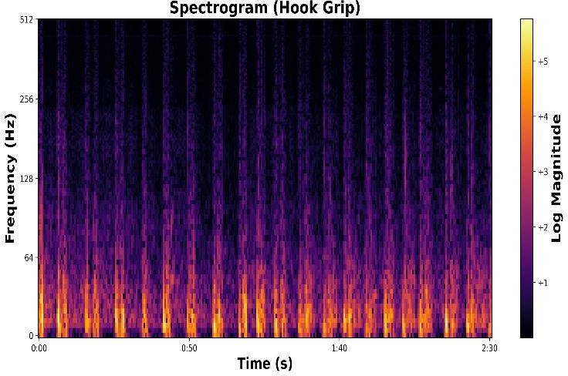  Hook_Grip
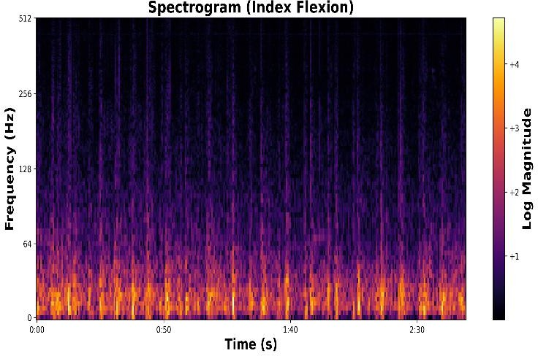  Index_Flexion | 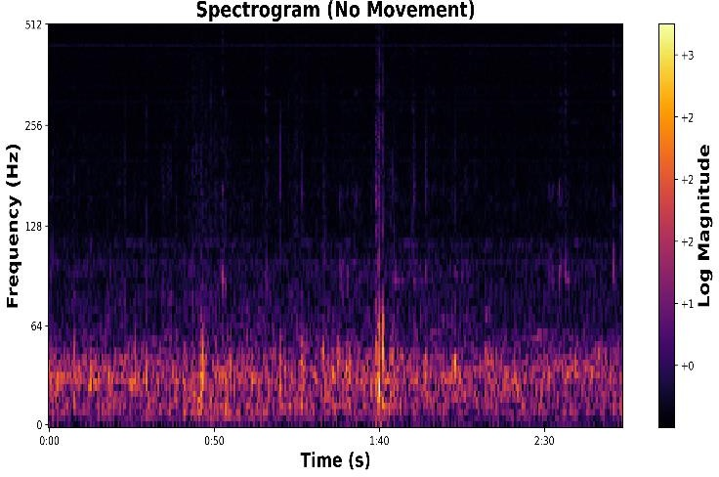  Rest

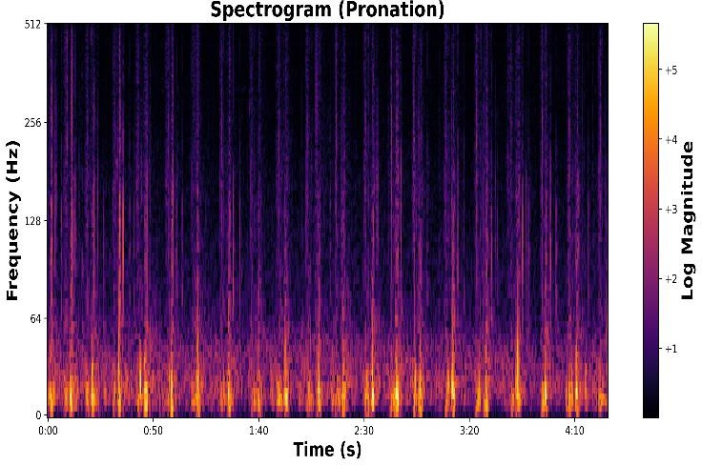  Pronation | 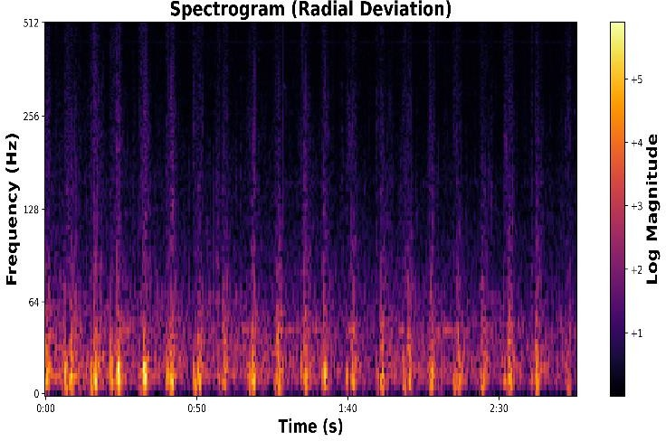  Radial_Deviation
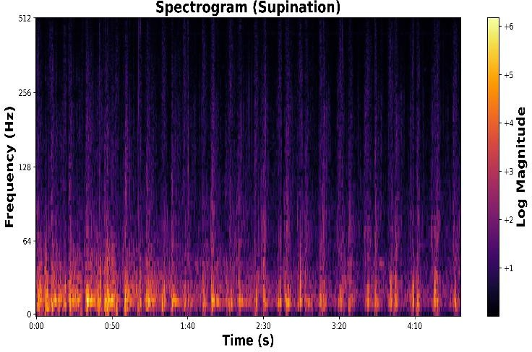  Supination | 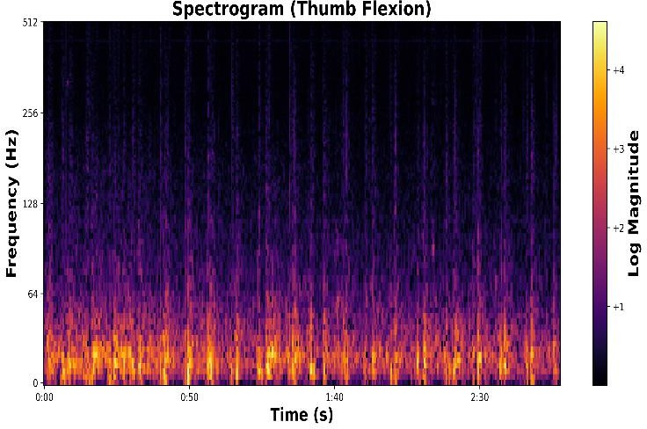  Thumb_Flexion
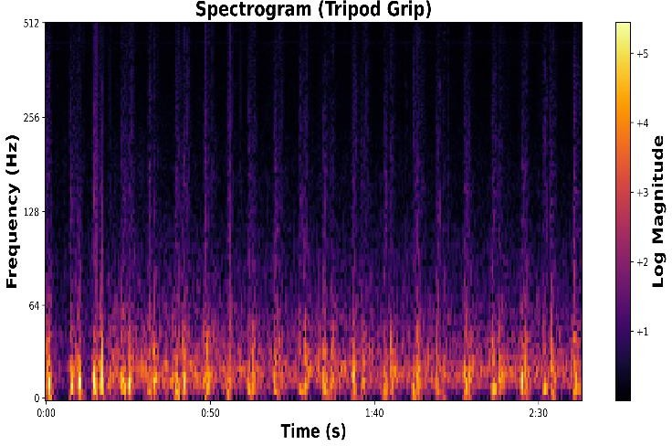  Tripod_Grip | 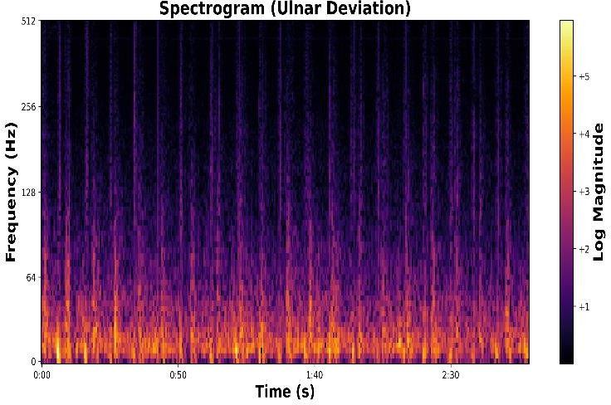  Ulnar_Deviation

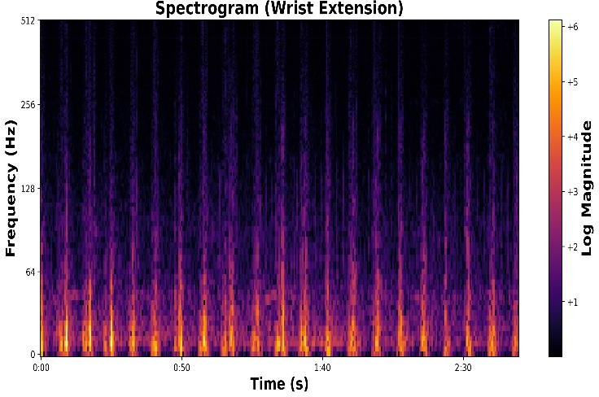  Wrist_Extension | 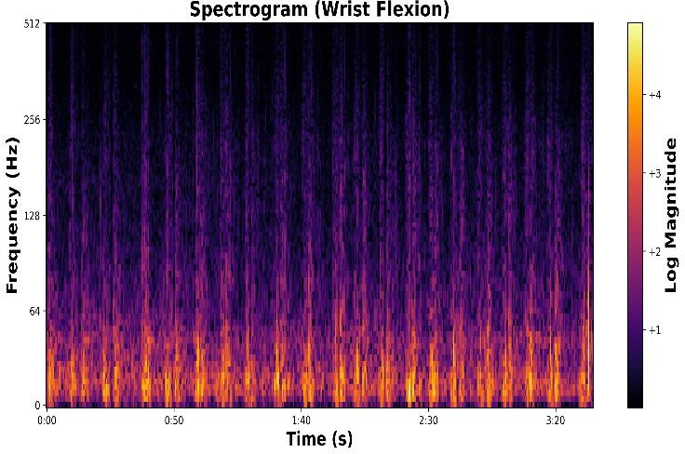  Wrist_Flexion

Figure 4.12: Time-frequency spectrograms of AMG signals for different classes of movements.

The time-frequency spectrograms of AMG signals in Figure 4.12 offer insight into the spectral characteristics of different hand and wrist gestures. For dynamic movements such as Fine Pinch, Hand Close, Hook Grip, and Tripod Grip, higher intensity bands were observed in the lower frequency range (0–100 Hz), indicating strong muscular activity. Movements involving gross motor control like Wrist Flexion, Wrist Extension, and Hand Open exhibited broader spectral energy spread with consistent low-frequency activation. In contrast, fine motor gestures such as Index Flexion and Thumb Flexion showed more localized energy bursts with relatively lower log-magnitude values.
Pronation, Supination, Radial Deviation, and Ulnar Deviation also demonstrated distinct activation patterns, where repetitive cycles and periodic spectral bursts were noticeable, particularly in the 0–150 Hz range. The No Movement class, serving as a baseline, showed minimal activity with mostly low log-magnitude across the spectrum, further validating the discriminative power of spectrograms in gesture classification.
These patterns indicate that spectrograms can effectively capture gesture-specific frequency dynamics, especially in the low-frequency domain where AMG signal power is typically concentrated.

CHAPTER-5

Discussion
This study explored the potential of Acoustic Myography (AMG) signals in hand gesture recognition (HGR), demonstrating their advantages over conventional EMG and vision-based systems. AMG’s non-contact nature and insensitivity to visual occlusions or lighting conditions position it as a promising candidate for wearable and ambient gesture recognition applications.
A core focus of the analysis was on the frequency-domain representation of AMG signals. The log-magnitude spectrograms and averaged power spectral densities revealed that most of the spectral energy lies below 100 Hz, with consistent patterns across gestures and subjects. Distinct spectral characteristics for each gesture class, particularly within the 0–64 Hz and 0– 100 Hz ranges, emphasize the discriminative strength of frequency-domain features for AMG- based gesture classification.
The comparison across deep learning models indicated that 1D-CNNs and TCNs are significantly more effective than LSTMs in leveraging frequency-domain data. The 1D-CNN achieved the highest accuracy and optimal latency-to-complexity ratio at the 250 ms window, making it particularly suitable for real-time applications, with varying latency requirements. TCNs, while slightly lower in accuracy, provided competitive performance with fewer parameters, offering another viable solution for embedded systems. The LSTM, in contrast, consistently underperformed in the frequency domain, showing its limitations in modelling AMG spectral patterns.
Additionally, spectrogram-based subject variability analysis highlighted subtle differences in spectral intensity and distribution across users. These variations underline the need for more diverse datasets and possibly subject-adaptive models to improve system generalizability.
Despite promising results, challenges remain. Microphone placement sensitivity and ambient acoustic noise can impact signal quality, and robust pre-processing or multimodal fusion strategies are required to mitigate such issues, such as the use of microphone arrays or sensor fusion with inertial measurement units.

CHAPTER-6

Conclusion and scope for Future Work

Concluding Remarks

This research has successfully established a robust framework for hand gesture recognition (HGR) utilizing Acoustic Myography (AMG) signals. By employing frequency-domain analysis and deep learning models, we achieved effective classification of 14 distinct gesture classes. The study compellingly demonstrates the consistent and discriminative information present in the spectral representation of AMG signals, which temporal convolutional networks effectively learned. The 1D-Convolutional Neural Network (1D-CNN) emerged as the most promising model, achieving a high classification accuracy of 94.56% at a 250 ms window size while maintaining computational efficiency. The analysis of spectrograms and power spectral densities further solidified the critical role of low-frequency components (below 100 Hz) in accurately differentiating gesture patterns, thereby validating the effectiveness of FFT-based preprocessing for AMG signal classification.
The outcomes of this research highlight the significant potential of AMG as a non-invasive, cost-effective, and practical alternative to traditional HGR methods such as Electromyography (EMG) and vision-based systems. Its inherent resilience to environmental noise and the advantage of non-contact sensing position AMG as a strong contender for next-generation HGR systems with wide-ranging applications.

Scope for Future Work

To propel this research towards real-world implementation and broader utility, future investigations should prioritize:

Enhancing Generalizability through Dataset Expansion:
Expanding the dataset to encompass a wider variety of users and operational scenarios to improve the model's ability to generalize across diverse populations.

Optimizing for Real-Time Deployment:
Focusing on refining model architectures and processing workflows to achieve minimal latency, enabling real-time performance on embedded and wearable devices.

Exploring Multimodal Sensor Fusion:
Investigating the integration of AMG with complementary sensing technologies like Force Myography (FMG) or Mechanomyography (MMG) to enhance the system's robustness and classification accuracy under varying conditions.

Developing a Practical Hardware Prototype:
Creating a lightweight and portable hardware system to evaluate the technology’s performance in real-world settings and assess its usability in practical applications.

References
- Z. Zheng, Z. Wu, R. Zhao, Y. Ni, X. Jing, and S. Gao, "A review of EMG-, FMG-, and EIT- based biosensors and relevant human-machine interactivities and biomedical applications," Biosensors, vol. 12, no. 7, p. 516, Jul. 2022. doi: 10.3390/bios12070516.
- M. Abdoli-Eramaki, C. Damecour, J. Christenson, and J. Stevenson, "The effect of perspiration on the sEMG amplitude and power spectrum," J. Electromyogr. Kinesiol., vol. 22, no. 6, pp. 908–913, Dec. 2012. doi: 10.1016/j.jelekin.2012.04.009.
- J. Petrofsky and M. Laymon, "Muscle temperature and EMG amplitude and frequency during isometric exercise," Aviat. Space Environ. Med., vol. 76, no. 11, pp. 1024–1030, Nov. 2005.
- A. A. Chaaraoui, J. R. Padilla-López, F. J. Ferrández-Pastor, M. Nieto-Hidalgo, and F. Flórez-Revuelta, "A vision-based system for intelligent monitoring: Human behaviour analysis and privacy by context," Sensors, vol. 14, no. 5, pp. 8895–8925, May 2014. doi: 10.3390/s140508895.
- P. Climent-Pérez and F. Florez-Revuelta, "Protection of visual privacy in videos acquired with RGB cameras for active and assisted living applications," Multimedia Tools Appl., vol. 80, pp. 23649–23664, 2021. doi: 10.1007/s11042-020-10249-1.
- S. Samui, S. Garai, A. Ghosh, and A. K. Mukhopadhyay, "Heterogeneous stacked ensemble framework for surface electromyography signal classification," in Proc. 10th Int. Conf. Pattern Recognit. Machine Intell. (PReMI), Kolkata, India, Dec. 2023, pp. 675–682. doi: 10.1007/978- 3-031-45170-6_70.
- A. A. Shaikh, A. K. Mukhopadhyay, S. Poddar, and S. Samui, "Toward robust and accurate myoelectric controller design based on multiobjective optimization using evolutionary computation," IEEE Sensors J., vol. 24, no. 5, pp. 6418–6426, May 2024. doi: 10.1109/JSEN.2023.3347949.
- S. Samui, "An experimental study on upper limb position invariant EMG signal classification based on deep neural network," Biomed. Signal Process. Control, vol. 55, p. 101669, 2020. doi: 10.1016/j.bspc.2019.101669.
- R. Sánchez-Reolid, F. López de la Rosa, M. T. López, and A. Fernández-Caballero, "One- dimensional convolutional neural networks for low/high arousal classification from electrodermal activity," Biomed. Signal Process. Control, vol. 71, p. 103203, 2022.
- A. H. Al-Timemy, Y. Serrestou, R. N. Khushaba, S. Yacoub, and K. Raoof, "Hand gesture recognition with acoustic myography and wavelet scattering transform," IEEE Access, vol. 10,
pp. 107526–107534, 2022. doi: 10.1109/ACCESS.2022.3212146.
- Analytics Vidhya. (2020). Exploring Different Types of LSTMs. Medium. Retrieved from https://medium.com/analytics-vidhya/exploring-different-types-of-lstms-6109bcb037c4
- S. Bai, J. Z. Kolter, and V. Koltun, "An empirical evaluation of generic convolutional and recurrent networks for sequence modeling," arXiv preprint arXiv:1803.01271, 2018. Original arXiv paper

